Chapter 9 - famous American cousins, Direct
Descendents of Richard Seymour of Sawbridgeworth, Immigrant to, and Founder of Hartford, and Norwalk

This and the following chapter just started off being a fun exercise, noting all of the relatively famous relatives, both in America and England (chapter 10). After compiling all of the information, I was surprised to see the distinct parallels between the British and American Seymours, and it was for me, the final piece of evidence that makes it clear that John of Sawbridgeworth, and therefore us, are clearly related to the ducal clan on the other side of the pond. There just can’t be that many coincidences. First a listing followed by their biographical summaries.

http://en.wikipedia.org/wiki/John_Seymour_(Maryland) “Colonel John Seymour was the 10th Royal Governor of Maryland from 1704 to 1709. He succeeded Thomas Tench and was succeeded by Edward Lloyd.” I found this guy when researching the branch of the family through John Seymour of Frampton Cotterell. This Colonel and Governor is not through our branch of Sawbridgeworth, but rather through Sir John’s illegitimate son John Seymour, who was the Protector’s half brother and his lawyer. He was thrown into the Tower along with Edward, but pardoned after Edward’s execution. He carved his name into a wall of the tower, and was a witness to the will of Edward’s son John, through Catherine Fillol, in 1552. “Upon his death, the family returned to England, so there are likely no American descendants from this immigrant.”
http://www.s560.com/dokuwiki/immigration

Col. Thomas Seymour (1735-1829), father of Major Thomas Youngs Seymour, GG Grandson of Richard, Major player in the Revolution and first mayor of Hartford for 28 years. http://www.s560.com/dokuwiki/book:083.thomas

Maj Thomas Youngs Seymour, Revolutionary War dragoon, son of first mayor of Hartford. http://www.stepneyrobarts.co.uk/2931.htm

Horatio Seymour (May 31, 1778 – November 21, 1857) was a United States Senator from Vermont.
http://en.wikipedia.org/wiki/Horatio_Seymour_(Vermont)

Horatio Seymour (May 31, 1810 – February 12, 1886) was an American politician. He was the 18th Governor of New York from 1853 to 1854 and from 1863 to 1864. He was the Democratic Party nominee for president of the United States in the presidential election of 1868, but lost the election to Republican and former Union General of the Army Ulysses S. Grant.
http://www.oneidacountyhistory.org/PublicFigures/Seymour/Seymour.asp

Thomas H. Seymour, Governor of Connecticut and military commander and hero, and Ambassador to Russia

General Truman Seymour http://en.wikipedia.org/wiki/Truman_Seymour (September 24, 1824 – October 30, 1891)

Origen Storrs Seymour (February 9, 1804 - August 12, 1881) http://en.wikipedia.org/wiki/Origen_S._Seymour

Edward Woodruff Seymour (August 30, 1832 – October 16, 1892) was a U.S. Representative from Connecticut http://en.wikipedia.org/wiki/Edward_Woodruff_Seymour

Brigadier General Henry Seymour Lansing http://www.iment.com/maida/familytree/lansing/henryseymourlansing.htm

Though in America, here’s an officially recognized descendant of the British branch. Frederick Seymour (born Belfast, Ireland, 6 September 1820 – died Bella Coola, British Columbia 10 June 1869) was a colonial administrator. He served as the second Governor of the Colony of British Columbia from 1864 to 1866, and the first governor of the union of the two colonies, also named the Colony of British Columbia from 1866 to 1869. http://en.wikipedia.org/wiki/Frederick_Seymour

http://s560.com/dokuwiki/book:051.john
LOUIS IRVING SEYMOUR had a colorful career. He was born at Whitney Point, N.Y., 23 Dec. 1860, and died at Zand River, Orange River Colony, South Africa, 14 June 1900

http://en.wikipedia.org/wiki/William_Seymour_(Congressman)
William Seymour was a United States Representative from New York. He was born in Connecticut about 1780, then moved to Windsor, New York about 1793

http://iqpedia.com/William%20Seymour%20Tyler/biography
William Seymour (1855-1933) was an American actor and director.

http://flammable.legalview.info/wikipedia/Polyurethane/
Raymond B. Seymour, PhD, is a scientist and educator whose discoveries have not only launched products and industries, but have also brought well-deserved recognition to the study of plastics.
http://en.wikipedia.org/wiki/Charles_Seymour
Charles Seymour (January 1, 1885 - August 11, 1963) was an American academic, historian and President of Yale University from 1937 to 1951.

http://en.wikipedia.org/wiki/Stephanie_Seymour
Stephanie Seymour, Model

http://www.ansp.org/library/getty_findaid/seymour820.xml
Samuel Seymour, famous pioneer artist--The first Anglo-American artists to travel west were Samuel Seymour and Titian Ramsay Peale, whom the federal government hired to accompany explorer Stephen

biographies

Col. Thomas Seymour another descendant of Richard through John (Thomas4, Thomas3, John2, Richard1), born at Hartford, Conn., 17 Mar. 1735, died there 30 July 1829 aged 94, for three years the oldest living graduate of Yale; married MARY LEDYARD, baptized at Groton, Conn., 15 June 1735, died at Hartford, 27 Aug. 1807, daughter of John and Deborah (Youngs).

He was graduated from Yale College in 1755, and became one of the most prominent citizens of his time. He represented Hartford in the General Assembly at eighteen sessions between 1774 and 1793, being Speaker five times, and from 1793 to 1803 was annually elected a member of the Connecticut Senate, then called the House of Assistants. He was King's Attorney, 1767, and after the Revolution, State's Attorney. He was commissioned Captain in the militia in 1773, and was promoted to Lieut.-Colonel, Oct. 1774.

During the Revolution (from Apr. 1775), he was head of the Committee of Pay Table, the labors of which fell mostly upon him, and Paymaster. As Lieut. Colonel of the 1st Regiment of Horse, he marched in command of three regiments of light horse in the summer of 1776, to aid the Continental Army in New York.

He was Chief Judge of the Court of Common Pleas, Hartford County, 1798 to 1803; first Mayor of Hartford, from its incorporation as a city, June 1784, until his resignation, at the age of seventy seven, May 1812.

He was one of the Trustees of the Grammar School. He was a member of the Second, or South, Church, as was also his wife, and in 1767 he was appointed to read the Psalm. He served this church as Deacon from 1794 until his resignation in 1809. He lived on Arch Street on the banks of the Little River; the house was pulled down in 1870, and the site was more recently occupied by apart of George S. Lincoln's iron foundry. General LaFayette stopped at his house when he was in Hartford in 1824. During the War of 1812, he was Commissary General.

“At the bar he is said to have been a smooth, persuasive, and engaging advocate; and in the various social and domestic relations he was as happy as his conduct was kind and exemplary.”

The character and cast of thought of the “First Mayor” are illuminated by a letter written by him in 1776 to Mr. Jedediah Norton and the Gentlemen of the Committee of the Society at Worthington:

“Gentln–I am informed by Doctor Steele that he is a sincere professor as well as Worshipper in the Church of England, and has for some time past paid to the Incumbent where he attends and has his receipt accordingly. This being the Case, hope you will not at least in this day of public calamity, put him or his Estate to any loss or Trouble especially for the building of meeting houses, & in a time when we are struggling for Civil & Religious Liberty tis perhaps a pity to Compel men to pay where they do not worship.

“I am with very great regard Gentlemen yr. Friend & h ble Se'nt

Thos. Seymour. – Hartford June 21 1776”

This letter, remarkable in that it was written by a Revolutionary patriot who had been King's Attorney, breathes a spirit of tolerance and real love of liberty not always found among the leaders of our Revolution and totally lacking among those hot-heads who dubbed themselves “Sons of Liberty.”

A framed autographed certificate issued by Thomas Seymour in 1802 as Mayor of Hartford, and bearing the seal of the City, is in possession of the Mayor's Office in Hartford.

The invaluable rolls of soldiers in the French and Indian War, 1755-64, were discovered and purchased by the late Judge Sherman Wolcott Adams of Hartford about 1888 after they had been removed from the old Seymour house on Governor Street, and later were acquired by the State Library. These muster rolls have been published in two volumes by the Connecticut Historical Society under the careful editorship of Albert C. Bates, Esq., who explains in the prefaces to the volumes how these papers came to be in the Seymour house, which descended from Col. Thomas Seymour to his son, Maj. Henry Seymour, in 1829, and from the latter to his son, Gov. Thomas H. Seymour, in 1846. After the death of the Governor's sister, her heirs in New Orleans, after removing what they valued, sold the house.

A letter addressed to President Jefferson, signed by Thomas Seymour and his son Henry, along with five other gentlemen, and possibly composed by Thomas Seymour, is of considerable historical interest, and is thought not to have been printed hitherto. We are much indebted to James L. Howard, Esq., of Hartford, Conn., for the copy. President Jefferson's reply to the letter may be found in the Works of Thomas Jefferson (Federal Edition, vol. 10, p. 366).

Hartford, Cont., Dec. 20, 1806

Sir:–

Apprehending that communications have been made to you, tending to misrepresent the sentiments of the Republicans in this State, on the subject of the prosecutions depending before the Circuit Court in this District, for Libels against the President & administration of the General Government; we submit the following observations, expressive of the opinions of the Republicans in this Town, and of the Friends of Republican Government in this State.

The Press we consider as essential to our Liberties; its liberty inviolable. In the liberty of the Press we include, the right to publish our sentiments on every measure of the Government; to examine it freely in all its tendencies; but not to charge its authors, with motives subversive of the liberties & happiness of the Nation.

The Chief Magistrate of a free government, becomeing the servant of the people, retains the rights of the Citizen. Devoting himself to his Country, the Country is pledged to secure to the Magistrate by all legal means the character of the Citizen. Renouncing the quiet of domestic life, & submitting his official conduct to the severe scrutiny of a people, jealous of their liberties; he consigns not his reputation as a man to rise and fall with the expediency or impolicy of his measures.

The opponents of the Gen. Government in this State, under the mask of superior virtue, religion, & patriotism, have commenced and persevered in, a systematic plan for the ruin of every Individual, who holds an office under, or advocates the Government of the U States. From the President, to the lowest officer, directly or indirectly dependent on him for appointment; fro:n the Republican Candidate for Governor down to the lowest Republican Candidate for office in the State Government; a continued torrent of abuse, not only copious and uninterrupted, but irresistable in its progress has issued. Not contented with this systematic attack on character; unsatisfied by the general wreck of reputation which has marked its progress, they are determined that the bare means of subsistance shall not be left to the victims of their intolerance. With these objects in view, not only suits at Law to rob us of our property, but criminal prosecutions have commenced. While on the other hand the characters and not the characters alone, but the opinions and conduct of Federalists, from the highest Judge to the most obscure Justs. of the Peace, are not only protected, but vindicated. The motives of men, who have rioted on the mangled reputations of their political opponents, in the Genl, & State governments, are not to be suspected without fine, & to the loss of property & character, have been added the horrors of Imprisonment. Confident that no Federal Court would take cognizance of calumnies against the President & administration, and influenced by the example of Political Priests, & of men high in office, under the State govermnent, who have descended from the Pulpit & the Bench to become the authors & retailers of the calumnies; Federal Editors, have unceasingly issued from their presses, libels as unprecedented in number and grossness, as they were unfounded in truth. While waging a war of extermination against the Characters of their political opponents, the professed friends of order in Connecticut had screened their own, by Juries openly & avowedly selected for the purpose. While, for publishing the truth of them in language not abusive, but decent, a Republican printer had been compelled to pay One Thousand Dollars; while another Printer & another Editor had been fined & Imprisoned; and while a persecuting & intolerant Majority were exulting over the distresses & misfortunes of an almost despairing minority; A Judge eminent for his talents & attatched to the Administration of his Country, by an unexpected order of Providence, is called to Preside at a Circuit Court in this District. A Grand Jury selected from among the most intelligent of our Citizens attatched to the principles which have uniformly guided the administration, but who will inviolably maintain the right of examining its measures, were summoned. Bills were found against a Judge, two political Priests, & three Federal printers, who were corrupting the taste and morals of the people. Public opinion has decided on the correctness of the procedure; moderate Federalists approve it; the violent are silent; and Republicans with a few solitary exceptions, applaud it.

Already Sir, have the public presses become less personal in their abuse, but have not nor will they become less free in their examination of the measures and principles of the Administration. Already has an Intolerant Majority softened its asperity, and a minority, despairing of Justice to itself from the State Courts, been led to anticipate from the Courts of the U States, exact Justice to its enemies.

Feeling ourselves wholly unrepresented at the seat of Government, we offer no apology for the freedom assumed; but tender you our ardent wishes for your happiness, and continued exertions, for the support & extension of Civil & Religious Liberty.
Thomas Jefferson Esq.
President of the U States.
Thos Seymour
Jonth. Bull
Sylvester Wells
Nathl. Patten
Daniel Olcott
Thos. Tisdall
Henry Seymour

“In October, 1789, while on a tour of two eastern states, Washington spent two days in Hartford. Mayor Thomas Seymour, who probably looked on the town hall as his regular place of business, for he was mayor for twenty-eight years, issued a proclamation welcoming His Excellency to Hartford and pledging loyalty and support. Washington replied to Mayor Seymour's welcome with a brief expression of thanks and pleasure.”

The will of Thomas Seymour, Esq., follows:

I Thomas Seymour of the City & County of Hartford in the State of Connecticut, Esquire, being at this present time, through the goodness of God, in good health, and of sound disposing mind & memory, yet knowing the uncertainty of this life, and that I cannot tell what a day may bring forth, but that it is surely appointed for all Men once to dye.-therefore now, in the fear of God, & in whose mercy alone, through Jesus Christ, I trust for salvation & happiness after this life, do make & ordain this my last Will & Testament, as follows, to wit.

Imprimis–That all my just Debts & funeral expenses shall be paid by my Executor, hereafter named.–

Item,–I give unto my Dearly beloved Wife Mary, the entire use and improvement of my Homestead, mansion House, & out Houses thereon–also, the use of all my household goods & furniture–a good Cow & Horse, & pasturing the same–& the sum of two hundred dollars, to be paid to her annually by my Executor–all, in lieu of Dower, during her natural life–

Item, as I have already given to my eldest Son Thomas Y. Seymour, by deed of gift, & otherwise, his full portion of my Estate, of considerable value, in which he expresed himself contented. so I give him nothing further at present–

Item, whereas I have done much for my son William Seymour, & he has had a full portion of my Estate, in money & payments made for him, therefore, it is my will that, he have nothing more, least it might deprive those of my Children, who have had little, of their just proportion–

Item, and whereas, I have given to my Son Edward Seymour, by deed of Gift, a considerable portion of my Estate, value six thousand dollars, at least, & the use of my Store a number of years, free of Rent; in addition to which, it is my will, & I do now give to him the said Store, & the platt of Ground on which it stands, near the south end of the great Bridge, with the priviledges & appurtenances, and to his heirs forever–

Item, I give to my dear & only Daughter, Mary Juliana Chenevard, all the Household Goods, furniture & plate, remaining in my House, upon the demise of her dear mother, excepting thereout, the Portraits of her Parents, & my Mohogany Desk & Book Case–and I also give to her one thousand dollars, to be paid to her by my Executor hereafter named, within six months after my decease, which I advise her to put upon Interest, for her own use–

Item–and whereas I have paid & advanced considerable sums of money for my youngest Son Ledyard Seymour, who has been unfortunate in Business therefore it is my will, not to give him any further at present, but to leave it to the discretion and affection of his Brother, my Executor hereafter named, to assist him, as far as he may judge it to be just & proper–

Item–I do give & bequeath unto my Son Henry Seymour, & to his heirs forever after the demise of his dear mother, my House & Homestead, containing about three Acres, together with all the rest, residue and remainder of my Estate, real & personal, not before given & devised; to enable him, (especially) to render his dear mothers life comfortable, and happy,–to meet & fulfill the other obligations enjoined upon him in this my will, as also, to make him equal to what has been done for his other Brothers, he, haveing as yet, had very little of my Estate, or other advancements–

and lastly, I do appoint my said Son Henry Seymour to be the sole Executor of this my last 'Viii & Testament, hereby revoking all other, & former Wills & Testaments, by me made–In witness whereof I have hereunto set my hand & Seal in the City of Hartford, this 20th day of August, in the year of our Lord, 1807–

Signed, sealed, published, & pronounced, in presence off–
Elisha Shepard
Elisha Babcock
Jona Wells Babcock
Tho. Seymour [seal]

Mayor Seymour in executing his will employed the seal charged with the two wings conjoined in lure, to be seen on the original will in the files of the Hartford Probate District. This is the same seal used by his father in executing his will in 1765, as before stated and as illustrated in the back pages of this volume.

dear Sir

I wanted to tell you an incident in the last days of my grandfather, Thomas Seymour King's atty first Mayor of the City of H–. He was ninety-four years of age when he died in 1827. It was his habit to rise very early and go down the bank of the little river, on which stood his office, and dip his head and neck into the river, then rush back to his room to make his toilette for breakfast. [p.2] When the river was frosen he broke a hole in the ice, performing the same ablutions the year round. I remember a summer day the last time perhaps that he came to see me in Asylum Street, cane in hand, he took the hand of my little daughter and placed in it a pair of sleeve buttons each crystal set in pure old gold, “Saying these are for your name Mary Ledyard–the name of your great grandmother.” The sweet loving look has always remained in my memory. Mrs Bailey is the owner of the precious buttons-Mary Ledyard Bailey. When he was fast failing and quickly closing away his mortal life, my mother attended him, his only daughter long a widow. He roused all of a sudden, “saying Julia I have lived a long and temperate life and tryed to set you all a good example”-then seemed nearly gone. She said do you know me father, no reply came, “Father do [you] know the Lord Jesus Christ? Oh yes I have known him a long time” came with emphasis, from his dying lips. Dear Mr Spring was my Pastor then, I went to him to attend the funeral. He said he never saw so fair, dignified and beautiful an object as he lay in his coffin. Such reminiscences to me are very sweet. I have to thank you for indulging me, in listening with so much interest to my old time legend-all facts-and not exaggerated. If I find any old papers that I think will interest your son or add anything to his researches, I will send them. There was an obscurity with regard to the grandfather's mother. His father was Thomas J, but G W Seymour tryed to find some notice of her, and asked me if I knew, but nothing more was said at the time, which seems rather singular

My love to Mrs Seymour

Yours truly, M. E. Comstock

Revolutionary War Patriots - http://books.google.com/books?id=FkFvyGcWxWwC&printsec=frontcover&dq=Abstract+of+Graves+of+Revolutionary+Patriot&hl=en&ei=zA8vTcqAIcKqlAfl_f3rCw&sa=X&oi=book_result&ct=result&resnum=1&ved=0CCIQ6AEwAA#v=onepage&q=seymour&f=false

At this site - a book “Abstract of Graves of Revolutionary Patriot”s By Patricia Law Hatcher, are listed the names of 32 Seymours who were killed in the War including 5 Captains. All of them from either Connecticut or upstate NY, and therefore we can assume descendents of Richard like us. One was a Jonathan Seymour buried at Whitestore which was an old crossroads near Sidney with a great little restaurant that me and Grandma Seymour liked a lot.
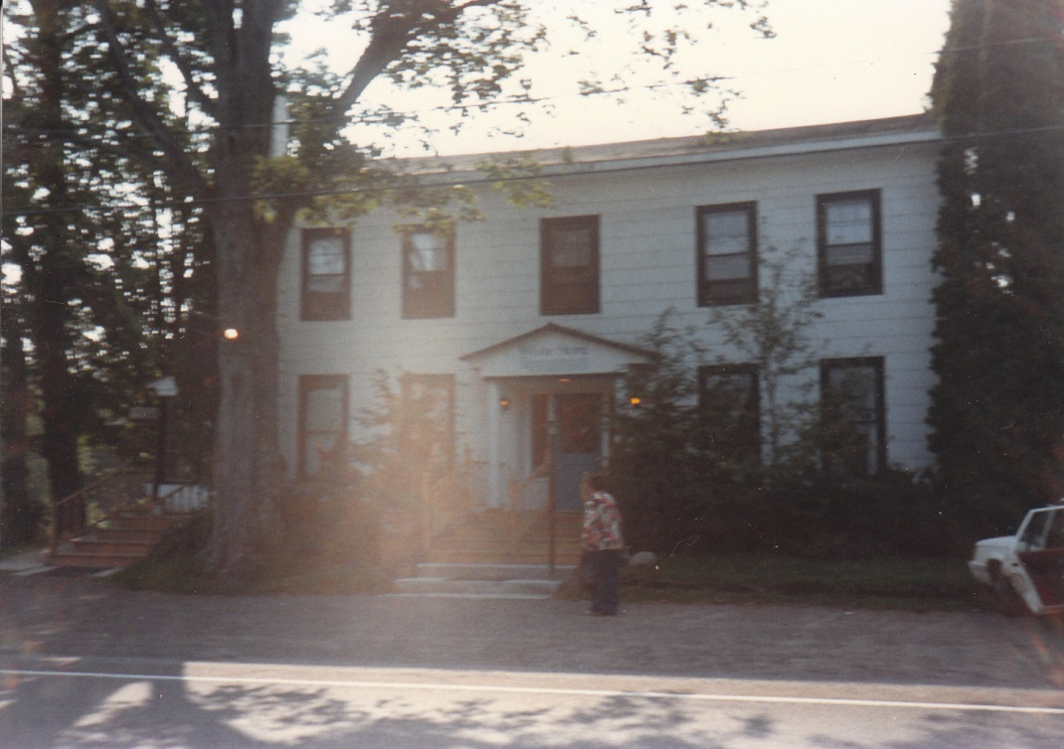Grandma going into the great little restaurant in the middle of nowhere, White Store, NY on Rt 8 between Sidney and Utica. Better food than I’ve found in many big cities around the world. Like a little French country Inn. I wish me and Grandma could eat there again, just one more time....

Major Moses Seymour http://www.litchfieldhistoricalsociety.org/museum/exhibit6.php Another descendant of Richard who played an important role in the American Revolution.
Here’s a letter written to him by a commanding officer:

“I am told, one landing South of this Place has a considerable Quantity of Wheat, & will not sell it_ use your own wisdom in the matter_ John Smith a little west of the Church_ has 30 Busshells to sell for hard money, but will have no hard damd Congress money_ pray sir impress it as your orders allow it, & justice demands it.” It sounds to me like Moses had to be a hard guy in order to feed the army. I wonder if he and John Smith were still friends....
Litcfield Historical Society, Miscellaneous Collections, Simon Newell to Moses Seymour, n.d.

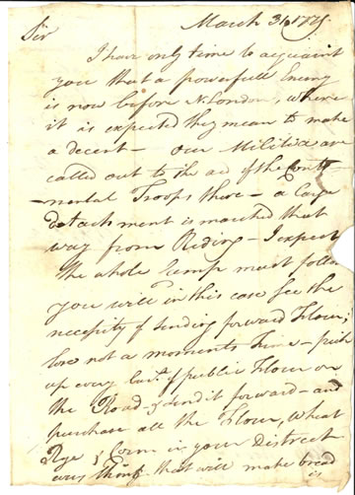
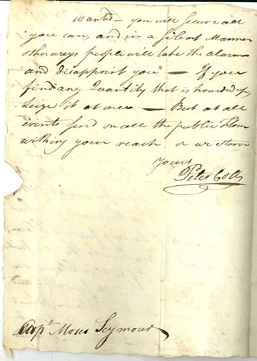

March 31. 1779
Sir
I have only time to acquaint you that a powerful Enemy is now before N. London, where it is expected they mean to make a decent_ Our Militia are called out to the aid of the Conti- nental Troops there_ a large detachment is marched that way from Reding_ I expect the whole Camp must follow you will in this case see the necessity of sending forward Flour; lose not a moments Time_ pick up every bush [bushel] of public Flour on the Road & send it forward_ and purchase all the Flour, Wheat Rye & Corn in your District everything that will make bread is

wanted_ you will secure all you can, and in a silent Manner other ways people will take the alarms and disappoint you_ If you find any Quantity that is hourded up, Seize it at once_ But at all events send on all the public Flour within your reach or we starve
yours
Peter Colt

Capt Moses Seymour

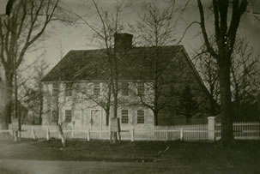Capt. Moses Seymour’s house

Officials were often given liberal parole to wander freely around the villages which held them. Major Moses Seymour was given the following orders pertaining to David Matthews, Royal Mayor of New York city and conspirator to kidnapp General Washington, “…you are directed and required to take him under your Care and him safely convey from Hartford in Hartford county to Litchfield ___ aforesaid and him there hold and keep in safe Custody permitting him only to walk abroad for the Benefit of the Air in the Day Time and to attend Divine Service at some place of public worship and that under your law or that of some other trusty keeper on the Sabbath Day, until you secure further Orders from me or from the Provincial Convention of the State of New York.”
Litchfield Historical Society, Woodruff Collection, Governor Jonathan Trumbull to Major Moses Seymour, August 22, 1776

Before further orders could be given, Seymour escaped. Loyalists in Litchfield were not limited to prisoners. Many local Anglicans remained loyal to the King, who was also the head of their church. Matthews later acknowledged the assistance of a local man, Joel Stone, in his escape. “I found...that from the confidence placed in him he would be a proper person to assist me in making my escape to New York which he readily undertook and carried me through the country at a very great risque of his life and property.”
Great Britain, Public Record Office, Treasury, Class I, Volume 634, folio I95.
Maj Thomas Youngs Seymour (1757-1811). Revolutionary War dragoon, son of first mayor of Hartford. A graduate of Yale College, 1777. Here again, Maj. Thomas is descended from our Richard but through John, and was the GGG grandson of Richard of Sawbridgeworth.
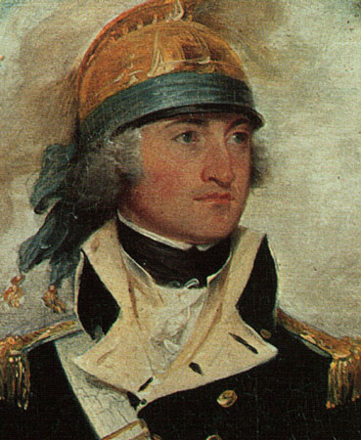

“After the surrender of British General Burgoyne, he was selected by Gen. Gates to escort the captive general to Boston, and performed this delicate duty so much to Burgoyne's satisfaction that at the end of the trip he presented him with a magnificent saddle and leopard skin saddle cloth and a brace of silver mounted pistols, which Major Seymour always took pleasure in using when in command of the Governor's Horse Guards.”

“In Trumbull's picture of the “Surrender of Burgoyne,” hanging in the rotunda of the Capitol at Washington, Captain Seymour is represented in the foreground mounted on a black charger.”
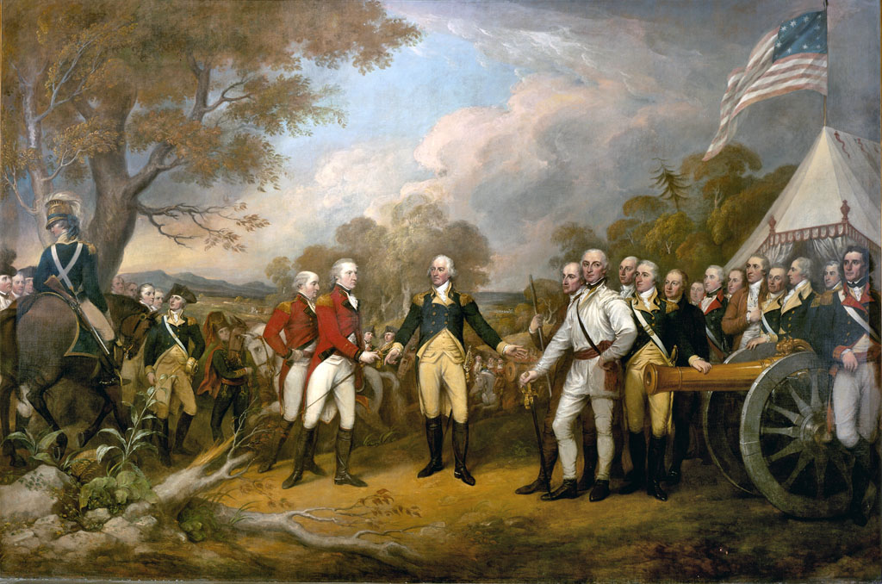

“John Trumbull’s painting Surrender of General Burgoyne was commissioned in 1817. The painting depicts the surrender of British General Burgoyne to the Continental Army at Saratoga, New York, in 1777 — a turning point in the Revolutionary War. The American General Horatio Gates stands in the center of the painting wearing a blue coat. Burgoyne, wearing red, is offering his sword to Gates, who refuses to take it. Trumbull, who served in the Continental Army under General Washington, painted each figure in the painting as a portrait of a specific officer.”

http://www.stepneyrobarts.co.uk/2931.htm “He (Seymour) participated actively in the Battle of Saratoga and at the Surrender of Burgoyne, acting as an aid on the staff of General Benedict Arnold. His company was called "the Blacks" from the color of their horses.

Col. Thomas Seymour of Hartford (the Major’s father), afterwards the First Mayor, wrote to Governor Trumbull, 22 Sept. 1777.

"Sir
I have the Honor to inclose your Excellency Copy of my Sons Letter, &
hope it may give some pleasure & Satisfaction- I am with very great
Esteem
Your Exclys
most obt
humble servt
Thos Semour"
The enclosed letter, a copy of that written from Camp by Thomas Y. Seymour, reads:

"Hond Sir

I now attempt to give a relation of an Engagment between the Enemys
whole Force & Genl. Arnolds Division, it began in the morning of the 19th.
instant between some Advanced Parties till noon, soon after which it became
General, and an unusual Fire continued the whole day, we obliging the Enemy
to quit the Field for three times, though they obstinately contended to keep
possession of it, - the Action was Bloody & would undoubtedly have been
decided, had not the Night parted us.-in the Course of the day 1000 were killed
of the Enemy, & 46 taken Prisoners all british Troops, as they were in Front,
& we lost in the above Action 34 kill'd 120 wounded & missing.-Some officers
of Distinction were lost on our side, such as two Colonels and some of a
less degree, the Militia of our State was engaged, & behaved bravely-Capt
Wadsworth of Hartford in particular has done himself eternal Honor, tho'
I am afraid [the] good man is mortally wounded-One of Mr Tucker's Sons
was instantly killed after acting the soldier.-Our Tents are all Struck, and
we momently expect to put an end to the Warr in this department, god
grant us success in a day so big with important Events-Genl Lincoln is in
the Rear of the Enemy, & will disappoint all possible hopes of their Retreat;
their Situation, a[s] I observed in a former Letter is desperate, for they
fought as if it was so, yet the Spirit of our Troops & Consciousness of the
Justice of our Cause made us an Overmatch for them-The Army still
Continue in Spirits and are doubly animated from the late Engag[e]ment-
I still Continue to be in health notwithstanding I experience great fatigues-
I am &c-
Thos Semour

P.S. Various Reports say Genl Burgoyne recd. a fatal Shot in the Action abovementioned-we are this day joined by 200 Indians of the Onoiada Tribe & with the Riflemen are now gone to beat up the Enemys quarters-This Letter I hope will be excused as it was written on my knee under Arms-Camp advanced of Still Water Sepr 20th 1777."

He resigned from the army in November, 1778, and took up the study of law in the City of Philadelphia. It is said that he visited Europe during this year, and devoted his particular attention to the study of military science in France. In 1780 he returned to Hartford and began the practice of law, having been admitted to the bar in that year. He acted as State's Attorney for Hartford County from 1796 to 1807, and represented the Town of Hartford in the General Assembly of the State of Connecticut at six sessions between 1795 and 1806. He was an active member in and one of the Committee of Correspondents in 1791 in an Anti-Slavery Society then existing in Connecticut, organized and carried on for the purpose of accomplishing the abolition of slavery in this country.

In 1787, a proposal was made to establish a volunteer troop of cavalry in Hartford County, to be called the Governor's Horse Guards, to be composed of some of the officers of the late army. Major Seymour was for some years commander of this organization, which included some of the wealthiest and most prominent citizens of Hartford, resigning in 1796.

In 1807 his health failed him, his mind becoming unbalanced, and he retired from business, never to return. He died May 16, 1811, at Hartford, aged fifty-four years.

Susan Bull Seymour, the second wife of Major Seymour, after his death applied for a pension, and in support of her claim filed, as she was required, affidavits to properly prove her right to same, which affidavits are on file in the Pension Office at Washington.

"I, Susan Seymour, formerly Susan Bull, hereby certify that the annexed
record taken from my Prayer Book is a true record of my marriage to
Thomas Y. Seymour, and the oldest record I possess.
(Signed) Susan Seymour.
Sworn to, etc."

Then follows a page cut out of an old prayer book, being Psalter for the thirtieth day, Psalms CXLVIII, CXLIX and CL, and in a woman's hand writing an entry in ink as follows:

"Thomas Y. Seymour married to Susan Bull, 30 Oct., 1784.

Their Children.

Tho. S. Seymour, born 6 Sept., 1785.
Mary Ann Seymour, born 16 June. 1789.
John Jay Seymour, born 5 Oct., 1791.
Charlotte Ann Seymour, born 19 Oct., 1794.
James Davenport Seymour, born 19 Dec., 1797,
who died 2 June, 1802.
Susan Elizabeth Seymour, born 6 May, 1800.
James Edward Seymour, born 21 Dec., 1802.
Egbert Davenport Seymour, born 9 Oct., 1806."

In addition, she filed the following:

"Being requested on behalf of Mrs. Seymour, widow of Thomas Y. Seymour, Esqr., late of Hartford, deceased. to state what I know respecting the said Seymour having served in the American Army during the Revolutionary War, do say, that all the information I have was derived from said Seymour himself with whom I was in habits of friendly intercourse for many years after the war. Major Seymour told me that he belonged to the Army of 1776, and served in New York in the memorable campaign of that year.
That he belonged to the Northern Army in 1777 and was present at the surrender
of Burgoyne, and that he then commanded the only troop of horse that belonged to that army. That he escorted the British officers to their station in the neighborhood of Boston, and that he received from Gen. Burgoyne a present of a very beautiful leopard skin to be used as a cover for the saddle in testimony of the General's estimation of the civil and obliging manner in which he performed his duty. The leopard skin I have often seen Major Seymour use while commanding the Horse Guards in this town. And I
further say that according to my recollection, I have heard Major Seymour say he retired from the Army in the year 1778 and entered upon the study of the law."

Hartford, Aug. 13, 1838.
(Signed) Nathl. Terry.

Sworn to, etc.

New Haven, 11 Aug., 1836.

Mr. Jesse Charlton,

Sir:
Your letter of the 9th is received, and in reply I have to say that I left the service in February, 1777, about the time that Col. Sheldon's Regiment of Light Horse (in which Mr. T. Y. Seymour commanded a company of troop), was raised. I therefore had personally no knowledge of his military service. But his reputation for gallantry and faithful conduct was such and so unquestioned that I felt myself perfectly justified in introducing his portrait in the picture of the Surrender of Burgoyne, and I have not the smallest doubt that his widow has a just title to whatever compensation the Government of the United States are accustomed to bestow upon the widows of their meritorious deceased officers of the Revolutionary War. With hearty wishes that Mrs. Seymour's application may be successful,

I am, Sir,
Your obedient servant,
(Signed) Jno. Trumbull.

The will of Susan Seymour of Bridgeport, Conn., dated 31 Dec. 1838, proved in Hampshire County, Mass., 5 May 1846, gave all her property to her daughter, Mary Ann Woodbridge, wife of Rev. John. At the time of her death, she was of Hadley where she had been spending her declining years at the home of her daughter, Mrs. Woodbridge. A daughter, Charlotte Ann Clark, appealed from the proving of the will; the testator had become insane and was sent to Worcester in 1843.

Thomas married Susan Bull, daughter of Amos Bull and Mindwell Pease, on 30 Oct 1784. (Susan Bull died on 9 Jan 1846 in Hadley, Massachussets.)

Horatio Seymour (May 31, 1778 – November 21, 1857) was a United States Senator from Vermont. He was the uncle of Origen S. Seymour and the great-uncle of Origen's son Edward W. Seymour.

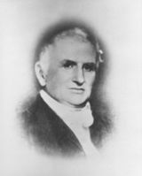

He was born in Litchfield, Connecticut on May 31, 1778. Seymour attended the common schools and graduated from Yale College in 1797. He taught school in Cheshire, Connecticut and pursued legal studies in Litchfield Law School. He was admitted to the bar in 1800 and commenced the practice of law in Middlebury, Vermont.

From 1800 to 1809, he was postmaster of Middlebury. He was a member of the State executive council from 1809 to 1814; he was the State’s attorney for Addison County from 1810 to 1813 and from 1815 to 1819.

In 1821, running as a member of the Democratic-Republican Party, he was elected to the United States Senate and served from March 4, 1821, to March 3, 1833. He did not run for re-election, instead running unsuccessfully for Governor of Vermont as a Whig.

He was a judge of the probate court from 1847 to 1856. He died in Middlebury, Vermont on November 21, 1857 and is interred in that town's West Cemetery.

Horatio Seymour, of New York, and Thomas H. Seymour, of Connecticut, were nearly related, were cadets together at Partridge's Military Academy in Middletown, and Governors at the same time, 1852, of their respective States. Horatio ran as the Democratic nominee for President, but lost to Ulysses Grant

http://www.oneidacountyhistory.org/PublicFigures/Seymour/Seymour.asp
“When Horatio Seymour died in 1886, the London Times of February 16 reported that “with few exceptions, he was the best of the American orators and was without exception whatever, the kindliest, most attractive, most valued of American orators, alike in his utterances and his personality”.

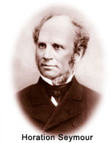

“In 1801, Henry Seymour, his wife and children left Litchfield, Connecticut, for a tract of land on Pompey Hill, some forty miles west of Utica, where Henry opened a store and dabbled in politics. When the Martin Van Buren faction won control of the canal board, they appointed Henry Seymour canal commissioner with the task of inspecting the construction of the middle of the Erie Canal.

The Seymours moved to Utica early in 1820 and took up residence in a brick house on Whitesboro Street facing south and almost on the bank of the canal. Horatio used to accompany his father on some of his inspection trips and he watched the boats passing east and west over the canal. Thus began his life-long love affair with the Grand Canal. Utica is a short drive up old Route 8 from Sidney.

Young Horatio attended various schools in Utica before his parents sent him to the academy in Geneva and then to a military academy in Middletown, better known for teaching drill formations than classics. His schooling completed, Horatio entered the law office of Green C. Broonson and Samuel Beardsley, both active Democrats. Beardsley, a close ally of President Andrew Jackson, exercised much power in the House of Representatives. Bronson, in 1854 ran for governor as a hard line Hunker Democrat who challenged Seymour, candidate of the regular Democrats, and took enough votes to cause the defeat of Seymour.

Horatio Seymour plunged into the world of politics when Governor Marcy appointed him his military secretary. A striking figure in his uniform, the six foot tall aide received many invitations to the homes of Albany aristocrats, a blend of Dutch patricians and transplanted Yankees. Horatio fell in love with Mary Bleecker, daughter of John Rutgers Bleecker, who had inherited many acres of land on both sides of the Mohawk River. Within two years, Horatio and Mary exchanged vows and their home became a center of gracious hospitality.

The rapid growth of Utica meant increasing wealth for the Seymour-Bleecker families. Even today, several Utica streets recall the given names of these families – Rutgers, Bleecker, Catharine, Miller to name a few.

The family wealth enabled Seymour to devote considerable time to politics and public service, including a term as mayor of Utica beginning in 1842. In 1841, he was elected to the New York State Assembly rising to the office of speaker in 1845. Party chieftains recognized his gifts as an orator and his talent as a conciliatory figure among warring factions. Six times the Democratic Party nominated him for the office of governor and twice he was victorious.

Seymour subscribed to the political philosophy of Thomas Jefferson – a weak central government, low taxes, free trade, reliance on freeholding farmers and artisans.

Seymour distrusted zealots such as ‘abolitionists, prohibitionists, and nativists because they disrupted party harmony and upset public concord.
As governor, Seymour faced not only the Whigs but also Democratic factions. He leaned toward the Hunker Democrats who favored grants for canal enlargement.

In 1860, he backed Stephen A. Douglas who won the nomination of the National Democratic party. Abraham Lincoln, however, won a majority of electoral votes although he attracted only 40 percent of the popular vote.

The shots by Confederate soldiers on Fort Sumter awakened New Yorkers to the reality of disunion, Seymour opposed the secessionists but he also criticized some of Lincoln’s actions as provocative and unconstitutional. He charged that Republicans arbitrarily arrested and by suspending habeas corpus were violating civil and political rights, The Republicans in turn accused Seymour of encouraging the rebels and obstructing efforts to put down the rebellion.

In 1862, Seymour accepted The Democratic nomination for governor and won by a comfortable margin. Seymour criticized the draft act passed by Congress in March 1863 as unfair because rich men could buy exemption and hire substitutes in order to avoid conscription. Moreover the federal government assigned New York state exceptionally high quotas by ignoring the exceptionally high number of volunteers who rallied to the colors in 1861.

In July 1863, after a weekend of grumbling in saloons about the draft, Manhattan workingmen formed a mob in protest and for three days roamed the streets. They burned the homes of abolitionists and even torched an orphanage for colored children. Although Governor Seymour put down the disorders, Republicans blamed him for encouraging the rioters.

In 1864 Seymour lost his race for a third term by the slim margin of eight thousand votes. The Democrats charged that the Lincoln administration obstructed agents of the Democrats from delivering ballots to soldiers and other dirty tricks.

Library at Marysland

The governor moved to Marysland, a five hundred acre farm in Deerfield where he and Mary Seymour could enjoy semi-retirement. Actually, their new wooden farmhouse soon became a regular stop for politicians, journalists, and family friends. Political leaders such as Samuel Tilden secured Seymour’s help in prying loose the hold of Boss Tweed on their party. In 1868 he presided over the Democratic national convention driven by factionalism. Unable to agree on a candidate, the delegates drafted Seymour, the only true draft by a major party in our history. 0f course, the Democrats, soon to be labeled the party of Rum, Romanism and Rebellion in the campaign of 1884, had only a slight chance of winning the election. This chance evaporated when the Republicans nominated a war hero, Ulysses S. Grant.
Ironically, one of Seymour’s bitterest opponents was his brother-in-law Roscoe Conkling, Republican leader in the Senate and a close ally of President Grant. Conkling had married Seymour’s youngest sister over the objections of Seymour. Whenever Seymour ran for office, Conkling campaigned strenuously against him, his brother-in-law.

Parlor at Marysland

Seymour took keen interest in history and education. He served as trustee of Hamilton College which awarded him an honorary degree. He became the first president of the Oneida Historical Society and planned the centennial celebration of the Battle of Oriskany. His welcoming speech at that event greatly impressed Harold Frederic, youthful reporter for the Utica Observer. Frederic dedicated his novel In the Valley to Seymour, whom he described as a “venerable friend to whose inspiration my first idea of the work was due”.

Seymour’s career straddled years of turmoil and progress. Throughout all this “an old humbug of a farmer” (his phrase) upheld Jefferson’s concern for democratic values, calmed angry voices, and raised the standard of public service.

No wonder the London Times discovered in Seymour a political leader comparable to luminaries in British public life. For Americans, however, a more apt comparison might be with that extraordinary galaxy of founding fathers who established a federal union, maintained local and state powers, and balanced the rights of individuals against those of society. If Marysland did not match Monticello in architectural quality, its gentleman farmer proved a worthy heir of Thomas Jefferson.

THOMAS Hart Seymour
http://www.onlinebiographies.info/gov/seymour-thomas.htm

From: The Governers of Connecticut
By: Frederick Calvin Norton
Published: 1905

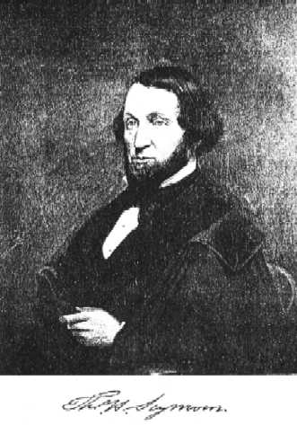

THOMAS Hart Seymour was descended from a celebrated English family who settled in that country as early as the thirteenth century. He was born in Hartford, September 29, 1807, and when very young displayed those traits which made him a leader of men afterwards. His early education was obtained in the public schools of Hartford, and as he showed a predilection for a military life he was sent to Captain Alden Partridge’s institute in Middletown. He pursued the course at this military school and was graduated in 1829. Returning to Hartford, Seymour was chosen as the commanding officer of the Light Guard of the city. He then studied law and was admitted to the bar in 1833, but before he gained much of a practice his love for politics changed his course in life. Becoming editor of “The Jeffersonian,” a leading democratic organ, he threw himself into the political discussion of the day. Seymour possessed a very attractive manner and a pleasing address, so that he was one of the most popular men of his time. He was elected judge of probate of the district, and soon occupied a position in the front ranks of the Hartford democracy, as their acknowledged leader.

In 1843 Seymour was elected a member of Congress, and when his term had expired he refused a renomination. He was commissioned in March, 1846, major of the Ninth or New England regiment of volunteers which took part in the Mexican war. Going to the front with his regiment, he served with such distinction that on October 13th, 1847, Major Seymour attained high military honors. The capture of Melino opened the way to Chapultepec, the Gibraltar of Mexico, which was the key to the City of Mexico. As it was built on a rock, impregnable on the north and well-nigh so on the eastern and most of the southern face, only the western and a portion of the southern sides could be scaled. The commanders decided, after a council of war, that it must be taken.
Two picked American detachments, one from the west and one from the south, pushed up the rugged steeps in face of an awful fire. The walls at the base of the castle fortress had to be mounted by means of ladders. One of these detachments was commanded by Colonel Ransom, but as that officer fell early in the assault, Major Seymour led the troops, scaled the heights, and with his command was the first to enter the fortress. The enemy was driven back into the city, and Seymour was placed in command of the regiment. He afterwards took part in the capture of the City of Mexico, and was present when it was fully in the hands of General Scott. When the war was over Seymour returned to Hartford and received the nomination for governor in 1849, but although there were Democratic gains over the preceding year he was not elected. The following year, however, he was elected governor of Connecticut by a large majority. Governor Seymour was re-elected in the years 1851, 1852 and 1853, serving with distinction. He also served as a presidential elector in 1852.

In April, 1853, President Pierce appointed Governor Seymour United States minister to Russia, and he immediately resigned his position as governor. He represented this country at the Russian court for four years, and during his residence there Governor Seymour formed a warm and lasting friendship for both the Czar Nicholas and his son. From them he received many costly tributes of their regard for him. After retiring from the position in 1857, Governor Seymour spent a year in travelling on the continent, returning to the United States in 1858.

Governor Seymour was bred as a Democrat and always upheld the principles of the party with true Jeffersonian tenacity. During the dark days of 1860 and 1861 he clung to the policy of the Democratic party. When the Southern states withdrew from the Union, and the Civil War was precipitated, Governor Seymour’s sympathies were with the South. He was opposed to the prosecution of the war until its close, and became leader of the Connecticut Peace Democracy.

On account of his pronounced opposition to the Union cause, the Senate of this state, in 1862, voted “that the portrait of Governor Seymour,” with that of Isaac Toucey, should be removed from the chamber till the comptroller should be satisfied of his loyalty to the Federal government. These portraits were taken to a place of safe keeping, and it is said that only one man in the city of Hartford knew where they were secreted.

In the Democratic party, however, Governor Seymour retained his old-time popularity and in 1863 he was again nominated for governor. Those were not the days for Democratic successes in Connecticut, and the contest which followed has probably not been equalled in this state.
After a most exciting canvass Seymour was defeated by William A. Buckingham of Norwich. At the Democratic National Convention, which met in Chicago on August 29, 1864, Governor Seymour received thirty-eight votes on the first ballot for president of the United States. He passed the remaining years of his life at Hartford, where he died on September 3, 1868.

General Truman Seymour http://en.wikipedia.org/wiki/Truman_Seymour (September 24, 1824 – October 30, 1891) The General is another descendent from our Richard but through son John rather than our Thomas. John seems to have spawned the bulk of the military and political leaders. Same Mom and Dad as Thomas, but grew up in the house of John Steele, Secretary of Conn & Mass. And received the inheritance that seems to have funded many later Yale educations.

“Seymour was a career soldier and an accomplished painter. He served in the Union Army during the American Civil War, rising to the rank of brigadier general. He commanded the Union troops at the Battle of Olustee, the largest Civil War battle fought in Florida.” Olustee is near Jacksonville, where I spent a large part of my life with no knowledge that a cousin had conquered the place 110 years before our arrival. He was named leader of the district of Florida, and was based in Jacksonville after invading and occupying it. Remember the GG Grandpa Alvin Cuyle had also passed through Jacksonville with the 144th Regiment.

Brigadier General Truman Seymour
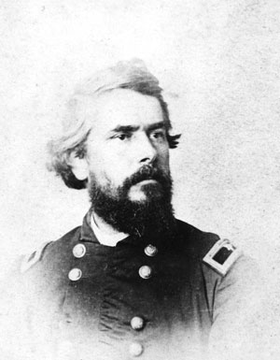 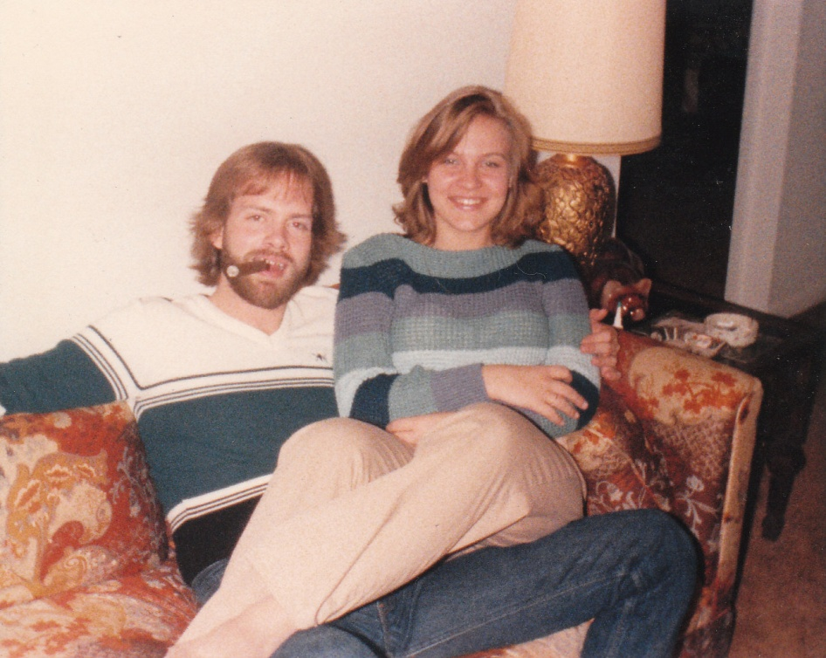Family resemblance? This was taken, ironically, in Jacksonville, Florida at about age 20 or 21 while a Freshman or Sophomore in College. Here in our first apartment with local born belle, and future mother of Tara Seymour. As you’ll see below, Truman enjoyed both a big triumph, and also maybe his biggest defeat here in Jacksonville. During my fifteen years or so in this strange town, I had plenty of both myself.

A couple of years before this photo I had been recruited by one of Truman’s almas mater, West Point, after scoring in the top 2 percentile of the PSAT exam in High School. They showed the 100 or so of us local candidates a recruiting film which included a description of Plebe life during the first two years at the Academy. It stated that Plebes weren’t allowed to have cars..... What??? That’s about the only part of the film that I needed to hear. I politely waited until the end of the presentation before leaving, but there was no way I was giving up my car.

I’ve mentioned that my Dad was a major hobbyist. He always had at least one or two hobbies going to occupy his free time. One of those I enjoyed sharing with him was playing a series of historically based war games by Avalon Hill. One of those games we had was 1776, obviously, I hope, based on the revolutionary war. Although I had no idea that an old relative had been a big player in the war, Major Thomas I’m referring to, I recall that when we played this game I particularly liked my dragoon unit. Maybe because, as I recall, they had a unique ability to get through swampy areas? Or maybe because Thomas was there with me assuring a repeat victory for the colonists? More likely, because when I was 12 or 13, I just liked saying the word “dragoon”. Who knows....

In this photo you also see that I’m continuing the family tradition with a St. Augustine rolled Habana. Later you’ll see that GG Grandpa Alvin started this tradition with his 1876 photo in his Civil War uniform.

Now let’s learn about the very full life of Cousin Truman:

“Seymour was born in Burlington, Vermont. The son of a Methodist minister, he attended Norwich University for two years before enrolling at the United States Military Academy at West Point. He graduated West Point in 1846 ranked nineteenth in a class of fifty-nine graduates. West Point’s Class of 1846 stands as one of the most illustrious in the academy’s storied history with George McClellan, Thomas J. “Stonewall” Jackson, Jesse Lee Reno, Darius Couch, George Stoneman, Sam Sturgis, David R. Jones, and George Pickett among its members. He was then assigned to the 1st U.S. Artillery.

He served in the Mexican-American War in 1846. During the war, he was promoted to the rank of first lieutenant for his performance in the battles of Contreras and Churubusco. After returning to the United States following the war, he was an assistant professor of drawing at West Point from 1850 to 1853 and fought against the Seminoles in Florida from 1856 to 1858. He was promoted to captain on November 22, 1860. Seymour was on duty at Fort Sumter when the South attacked and the Civil War began and was brevetted a major for his actions during the Confederate attack. He led troops during the battles of Second Manassas, South Mountain, and Antietam, resulting in two brevet promotions in the regular army up to colonel. In November of 1862, he was reassigned to Charleston Harbor and led a failed attack on Battery Wagner, in July of 1863, where he was severely wounded.

When Seymour returned to duty in December of 1863, Maj. Gen. Quincy A. Gillmore, commanding general of the Department of the South, placed Seymour in charge of the newly created District of Florida. The division made an expedition to Florida in February 1864, landing at and taking possession of Jacksonville. Subsequently, Gillmore returned to South Carolina and left Seymour in tactical command.
On February 20, Seymour’s force of about 5,500 men met a Confederate force of about 5,000, commanded by Brigadier General Joseph Finegan. The battle took place near the town of Olustee, about 40 miles west of Jacksonville. The ensuing battle produced some of the heaviest losses, by percentage, of any major battle of the war. Although Seymour’s division inflicted nearly 1,000 casualties, it received nearly 2,000 in return. General Seymour’s force returned, defeated, to Jacksonville, where Union troops retained control until the war ended. Seymour was also present at the surrender of Lee making him one of only two men present at both Fort Sumter where the war started and at Appomattox where it ended.

After the war ended, Seymour stayed in the Army. He served again in the 5th Artillery, and later commanded forts in Florida, Fort Warren, Massachusetts (1869–70), and Fort Preble, Maine (1870–75). He retired from the army on November 1, 1876.”

“He received the degree of Artium Magister (a masters in art) from Williams College in 1865. Seymour spent his retirement in Europe. He painted much in watercolor, and died while living in Florence, Italy in 1891. He was buried there in the Cimitero Evangelico degli Allori.” That’s cool. I wish I had known that when we visited Florence. If I make it back I’ll visit the grave.

See the remainder at the Wikipedia link above.

More about his wife, painting and retirement in Europe. http://www.askart.com/askart/s/truman_general_seymour/truman_general_seymour.aspx “A watercolorist who was primarily a military man, Truman Seymour spent his retirement in Europe and did his most productive painting there. His work focused on changing light and color, and he also did vast panoramic views, reflecting his training in aerial perspective from West Point Academy.

Most of his paintings were held by his family after his death in 1891 and were not available for public viewing until the Richardson-Clarke Gallery in Boston acquired a number of them in the late 1990s. Two exceptions were special exhibitions, one of them curated by Kent Ahrens at West Point in 1974 and the other by the Everhart Museum in 1986.

Seymour was educated at West Point Academy in New York where drawing classes were required, and in 1850, he became drawing teacher at the Academy under the direction of Robert W. Weir. Seymour married Weir's daughter, Louisa, and began a lasting friendship with her two brothers, Julian Alden and John Ferguson Weir. The Weir’s were a famous family of artists.

In 1876, he retired with poor health (chronic bronchitis and congenital heart disease), and he and Louisa moved to Europe in 1877, living first in London where they were joined by J. Alden Weir. They visited with James Whistler (famous artist who also studied under Weir and later painted Whistler’s Mother which is now at the Louvres, among many more), who had been a cadet at West Point during Seymour's period there.

The couple also lived in Paris and Italy, where their home ultimately became Florence. During this time, he produced the vast majority of his watercolors, capturing the hot Mediterranean sun, colorful market scenes and fragmentary architectural settings.”

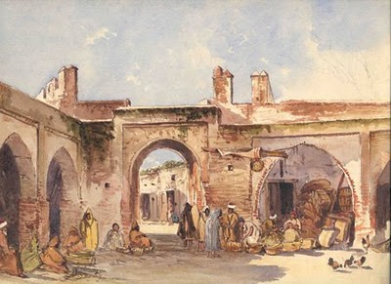Market Tangier, by Truman Seymour

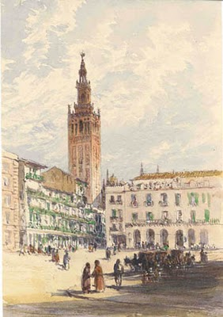Plaza del Ayuntamiento with La Giralda, Seville by Truman Seymour

Seymour watercolors from Martha Richardson Fine Art Gallery, Boston, Massachusetts. To see more of Seymour's paintings, visit: http://www.martharichardsonfineart.com/artist_catalog_thumbnails.asp?id=1721680292

Although a strange and unknown kind of factoid, according to this website, Truman also set up the military bugle call system, including Taps -- http://www.justanswer.com/questions/1kgmd-i-have-an-analysis-of-the-poem-the-deserter-by-housman-to. “By the end of the Civil War the artillery, cavalry, and infantry were sounding bugle calls. In 1867, General Emory Upton directed Major Truman Seymour, 5th U.S. Artillery, to prepare a definitive system of calls with the object of eliminating the confusion evident during the Civil War. Major Seymour reviewed all the calls then in use in the Army. He discarded some, revised others, and finally fashioned the set of calls which have remained in use up to the present time. In 1867, bugle calls were standardized for all branches of the Army. The enlisted soldiers life was regulated by bugle calls: the daily routine included breakfast, dinner, and supper calls; fatigue call, drill call, stable and water calls, sick call, and taps. On Sundays, the church call was added to the daily schedule.”

Origen Storrs Seymour (February 9, 1804 - August 12, 1881) was a U.S. Representative from Connecticut, father of Edward Woodruff Seymour and nephew of Horatio Seymour.

Born in Litchfield, Connecticut, Seymour attended the public schools and was graduated from Yale College in 1824. He studied law. He was admitted to the bar in 1826 and commenced practice in Litchfield, Connecticut. He served as county clerk 1836-1844. He served as member of the State house of representatives in 1842, 1849, and 1850, and served as speaker in 1850.

Seymour was elected as a Democrat to the Thirty-second and Thirty-third Congresses (March 4, 1851-March 3, 1855). He served as judge of the superior court of Connecticut 1855-1863. He was an unsuccessful Democratic candidate for Governor in 1864 and 1865. He served as judge of the State supreme court in 1870, chief justice in 1873, and served until retired by age limitation in 1874. He served as chairman of the commission to settle the boundary dispute between Connecticut and New York in 1876. He was again a member of the State house of representatives in 1880. Seymour was the first president of the Connecticut Bar Association. He died in Litchfield, Connecticut, August 12, 1881. He was interred in East Cemetery. http://en.wikipedia.org/wiki/Origen_S._Seymour

Edward Woodruff Seymour (August 30, 1832 – October 16, 1892) was a U.S. Representative from Connecticut, son of Origen Storrs Seymour, great-nephew of Horatio Seymour.

Born in Litchfield, Connecticut, Seymour attended the public schools and was graduated from Yale College in 1853. He studied law. He was admitted to the bar in 1856 and practiced in Litchfield and Bridgeport, Connecticut. He served as member of the State house of representatives in 1859, 1860, 1870, and 1871. He served in the State senate in 1876.

Seymour was elected as a Democrat to the Forty-eighth and Forty-ninth Congresses (March 4, 1883-March 3, 1887). He resumed the practice of his profession. He was appointed as a judge of the Connecticut Supreme Court in 1889. He died in Litchfield, Connecticut, on October 16, 1892. He was interred in East Cemetery. http://en.wikipedia.org/wiki/Edward_Woodruff_Seymour

Charles Seymour (January 1, 1885 - August 11, 1963) was an American academic, historian and President of Yale University from 1937 to 1951. Here’s another descendant of Richard but the whole trail isn’t available on the internet. His father and grandfather were also notable professors, and they had found themselves over in Ohio, after traveling and studying through Europe.

Seymour was born in New Haven, Connecticut, the son of Thomas Day Seymour, who taught classics at Yale. His paternal grandfather, Nathan Perkins Seymour, was the great-great grandson of Thomas Clap, who was President of Yale in the 1740s. His paternal grandmother, Elizabeth Day, was the grandniece of Jeremiah Day, who was Yale's president from 1817 through 1846. An ancestor of his mother, the former Sarah Hitchcock, was awarded an honorary degree at Yale's first graduation ceremonies in 1702.

Seymour was awarded a Bachelor of Arts at King's College, Cambridge in 1904; and he earned a second B.A. from Yale in 1908. He went on to earn a Ph.D. from Yale in 1911.

Seymour's teaching experience began at Yale in 1911 when he was made an instructor in history. He was made a full professor in 1918; and when he eventually left teaching, he had risen amongst the faculty to become Sterling Professor of History (1922-1927). He taught history at Yale from 1911 through 1937, when he became president of the university.

Seymour served for ten years as the university's provost (1927-1937). During this period, Yale College was re-organized into a system of ten residential colleges, instituted in 1933 with the help of a grant by Yale graduate Edward S. Harkness, who admired the college systems at Oxford and Cambridge. Seymour became the first Master of Berkeley College.

At age 52, Seymour succeeded James Rowland Angell as the university's 15th president in October 1937. After his retirement in July 1950, he would be succeeded by Alfred Whitney Griswold.

Seymour served as the chief of the Austro-Hungarian Division of the American Commission to Negotiate Peace in 1919. He was also the U.S. delegate on the Romanian, Yugoslavian, and Czechoslovakian Territorial Commissions in 1919.

After his retirement as president, Seymour was continued his involvement with the university as curator of the papers of Edward M. House at the Yale University Library.

He died in Chatham, Massachusetts in 1963 after a long illness. His son, Charles Seymour, Jr., was a professor of art history at Yale.

Quote: "We seek the truth and will endure the consequences."

Brigadier General Henry Seymour Lansing (17 Feb 1823 - 14 Apr 1882, Burlington NJ)

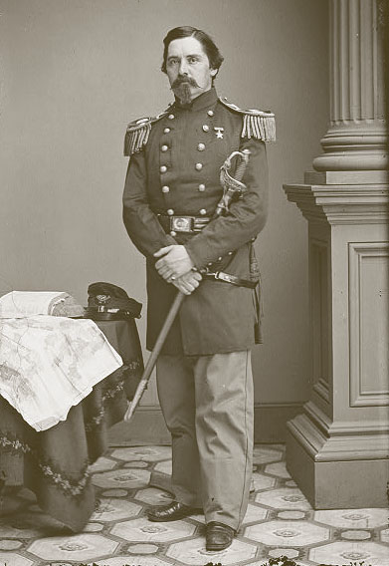 http://www.iment.com/maida/familytree/lansing/henryseymourlansing.htm

Here we have another cousin through the line of Richard’s second son, John. One of the Utica Seymours, and therefore closely related to Horatio. Interesting to note that when he wasn’t leading brigades in war time he was an accountant like me.

“Colonel Henry Seymour Lansing, Henry Livingston Lansing's brother, commanded the 17th New York Volunteer Infantry. The regiment was formed on May 29, 1861 for a two year term and Colonel Lansing commanded it from its inception until it was disbanded on June 2, 1863. He had also been active in the formation of New York's Military Association before the war.

Being surrounded by southern sympathizers, there was a great concern for the protection of Washington from the start of hostilities. Colonel Lansing's regiment was first assigned to that duty. From April to May of 1861, Colonel Lansing participated in the Siege of Yorktown, the very place where his grandfather, Colonel Gerrit G. Lansing, had fought in the Revolutionary War.

That summer, they fought in the Seven Days Battle before Richmond Virginia and by October, the 17th had been transferred to the Army of the Potomac and became involved in some of the worst Civil War battles, fighting with heavy losses at the second battle of Bull Run, Antietam and the Battle of Frederickburg and Chancellorsville. The first three of these battles is fictionally described in Gods and Generals by Jeffrey M. Shaara.” Remember that Truman also fought in the 2nd Bull Run and Antietam

“HEADQUARTERS FIFTH CORPS
October 14, 1862

Brig. Gen. SETH WILLIAMS
Asst. Adjt. Gen., Headquarters, Army of the Potomac:

GENERAL:
I respectfully present to the consideration of the commanding general the following recommendations for promotions, with the hope that they may be favorably presented to the honorable Secretary of War: Col. H. S. Lansing, Seventeenth New York Volunteers (captain Twelfth U.S. Infantry), to the rank of brigadier-general. The activity and energy of this officer from the commencement of the war commend him to the consideration of the commanding general for reward. His efficient services in the field, commanding his regiment and at times a brigade or an expeditionary force, prove his soldierly qualities and his ability to fill the position. I would like to have him command a brigade of this corps.

I am, general, very respectfully, your obedient servant,
F. J. PORTER
Major-General, Commanding

At the end of the war, Colonel Lansing was promoted by brevet to Brigadier General for his short command of the Bull Run battlefield. In 1877 he was auditor general of the Centennial Board of Finance, Philadelphia.”

Death Certificate
Henry Seymour Lansing
Age: 58 years 2 months White
Married Accountant
Birthplace: Utica NY
Last place of residence: Burlington
How long resident: Six months
Place of death: Corner Broad and High Streets; Burlington City
Father's name Bleecker B. Lansing U.S.
Mother's name Sarah U. Seymour
I hereby certify that I attended H. Seymour Lansing during the last illness and that he died on the 13th day of April, 1882.
Length of sickness: two years
Edward S. Lansing, Medical Attendant
Residence: Corner Stacy and Union
Date: April 17, 1882
Undertaker: E.F. Perking Burlington City NJ
Burial: St. Mary's Church Grounds Burlington City N.J.

Frederick Seymour - Seymour was the son of Henry Augustus Seymour, who was himself the illegitimate son of Francis Seymour-Conway, 2nd Marquess of Hertford. In this case not a descendent of Richard, but from other cousins in Herts. Upon the latter's death in 1822, Seymour's father was forced to surrender his civil service position and property, and leave Ireland for Belgium. In 1842, Prince Albert helped secure a position for Seymour in the colonial service. For the next twenty years, he served in various positions in a series of colonies mired in political and economic difficulties: Van Diemen's Land, Antigua, Nevis, British Honduras, and the Bay Islands.
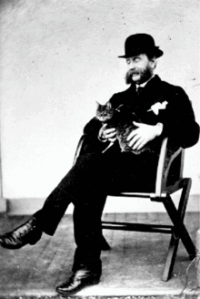

In 1864, Seymour attained the apogee of his colonial career as successor to Sir James Douglas as Governor of the Colony of British Columbia. He inherited an administration deeply in debt, and a restless population of British colonists, demanding responsible government. Seymour continued with his predecessor's project of building wagon roads into the gold mining districts of the Cariboo, and helped put down a First Nations insurrection at Bute Inlet. He was, however, resistant to pressure to amalgamate British Columbia with the Colony of Vancouver Island in order to help consolidate the revenue and debts of the two colonies and reduce administration costs. Eventually he relented, and the colonies were united in 1866. Seymour was named governor of the new united colony.

The next three years were unhappy ones for Seymour, as he battled a succession of illnesses, and faced an increasingly restless population. After the Canadian Confederation in 1867, sentiment turned strongly towards the colony seeking admission as a province of Canada. Seymour was lukewarm to the proposal, but regained much of the goodwill he had lost by successfully improving both the economy and infrastructure of the colony, culminating in the construction of a graving dock at Esquimalt.

His term slated to end in 1869, Seymour made one last journey as governor to the Nass River, on the northwest coast of the colony, to mediate a dispute between First Nations tribes. While returning, he became ill with dysentery and died at Bella Coola.

Places named for Frederick Seymour
Mount Seymour is a peak, a provincial park, and ski hill located in the Coast Mountains northeast of Vancouver, British Columbia. There are two other, much lower, Mount Seymours; one on Quadra Island, offshore from the town of Campbell River, the other on Moresby Island in the Queen Charlotte Islands.
There are two watercourses named the Seymour River. One flows from Mt. Seymour to Burrard Inlet, and the other into Shuswap Lake.
Seymour Arm is an arm of Shuswap Lake, British Columbia.
Seymour Inlet is located in a maze of inlets on the north flank of Queen Charlotte Strait.
Frederick Sound are located on the northern British Columbia coast opposite the Queen Charlotte Islands.
There are two bands of mountains named the Seymour Range in British Columbia. One is located on Southern Vancouver Island, and the other north of Shuswap Lake in the upper reaches of the Seymour River, at the head of which there is a Seymour Pass.
Seymour Street is a major north-south artery in downtown Vancouver, bounded to the south by the Granville Street Bridge, and to the north by Cordova Street.
Seymour Landing on Seymour Bay, on the southeast coast of Bowen Island, just west of West Vancouver.
Seymour Island, an islet in Sunderland Channel on the north coast of Hardwicke Island, in the Johnstone Strait area between Vancouver Island and the mainland to the north of it.

Henry William Seymour (July 21, 1834 - April 7, 1906) was a politician from the U.S. state of Michigan.

Seymour was born in Brockport, New York and attended the public schools, Brockport Collegiate Institute, and Canandaigua Academy. He graduated from Williams College of Williamstown, Massachusetts in 1855. He studied law in Albany, New York taking lectures at Albany Law School and was admitted to the bar in May 1856, but never practiced.

Seymour engaged in mercantile pursuits in Brockport until 1872 when he moved to Sault Ste. Marie, Michigan where he engaged in the manufacture of reapers and subsequently in the manufacture of lumber and in agricultural pursuits. He was a member of the Michigan House of Representatives from Cheboygan District, 1880-1882 and a member of the Michigan Senate 1882-1884 (31st District) and 1886-1888 (30th District).

In a special election on February 14, 1888, to fill the vacancy caused by the death of Seth C. Moffatt, Seymour was elected as a Republican from Michigan's 11th congressional district to the 50th Congress, serving from February 14, 1888, to March 3, 1889. He was an unsuccessful candidate for re-nomination in 1888, losing to fellow Republican Samuel M. Stephenson in the primaries.
Henry W. Seymour died at the age of seventy-one, while on a visit, in Washington, D.C. He is interred at Lakeview Cemetery of Brockport.

Although not our William Jr., this guy ran a parallel course. He was born over in Connecticut just “about” five years before William Jr. and moved into the same neighborhood, next door to Delaware County just seven years before William Jr. got to Cannonsville. This William apparently arrived with his parents, as he was only about 13 at the time.

William Seymour was a United States Representative from New York. He was born in Connecticut about 1780, then moved to Windsor, New York about 1793. He attended public schools, studied law, was admitted to the bar, and commenced practice in Binghamton. He returned to Windsor in 1807 and served as justice of the peace. In 1833, upon his appointment as first judge of the Court of Common Pleas of Broome County, he returned to Binghamton.

Seymour was elected as one of the first trustees of the village in 1834. He was elected as a Jacksonian to the Twenty-fourth Congress (March 4, 1835-March 3, 1837). He again served as first judge of Broome County until 1847, resumed the practice of his profession in Binghamton where he died December 28, 1848. His interment was in Binghamton Cemetery.

Although maybe not exactly famous, this guy Louis caught my attention as it’s so obvious to me that we’re related, and I admire his life. Also, Whitney Point is next door to Delaware County, and we passed through there many, many times. Louis is descended down from Richard and our Thomas, although not through Capt. Matthew, but rather his younger brother John. Remember that John died a very rich man, which apparently has funded a few more Yale educations, but none were necessary for Louis. http://s560.com/dokuwiki/book:051.john

LOUIS IRVING SEYMOUR had a colorful career. He was born at Whitney Point, N.Y., 23 Dec. 1860, and died at Zand River, Orange River Colony, South Africa, 14 June 1900; married 30 June 1886, Kate Perry of Whitney Point. No children.

Mr. Seymour was educated in his native village, and being mechanically inclined, at the age of seventeen entered the machine shops of John Cotter at Norwalk, Conn. His 2 older brothers graduated from Yale Law and became lawyers, having a firm in NYC (Seymour, Seymour & Megrath) but Louis was some kind of mechanical genius and thought college was unnecessary. After working there three years, he went up for examinations at Annapolis, but after passing it was found that he was a few weeks too old, so he had to abandon the hope of a career in the U. S. Navy. After working for the Lackawanna Iron and Coal Company from 1881 to 1884, he accepted at the age of twenty-four an engagement offered by the Dickson Manufacturing Company to erect a mill engine for EI Callao Gold Mining Company in Venezuela. After finishing the erection, he was retained as the chief mechanical engineer of the company.

Early in 1886 he returned to the United States, and a few months later married his boyhood sweetheart. At this time he held positions with the Washington Cotton Mills of Lawrence, Mass., and with the Plymouth Cordage Company of Plymouth, Mass. While working with the latter he became more widely known, and in Feb. 1890 he was engaged to proceed to Kimberly in South Africa, where he took up the work of chief mechanical engineer for the De Beers Consolidated Mines.

In July 1893, he became managing director of Fraser and Chalmers, Erith, England, at the same time retaining the position of consulting engineer to the De Beers Consolidated Mines. In 1896 he returned to Africa, and in that connection the following story is told. It is said that a group of English capitalists invited Seymour to dinner, after which his host asked him whether he could be induced to return to South Africa. “I could be,” said Seymour, “but it would cost money.” “How much?” inquired his host. “Fifty thousand dollars a year,” was Seymour's prompt rejoinder. Man, that was a lot of money in 1896, and I’m sure there weren’t any taxes being withheld, or 1099’s issued.

His terms were accepted, and he took up his residence in Johannesburg, holding the position of mechanical engineer to Messrs. H. Eckstein and Company and the Rand Mines, Limited. At the outbreak of the Boer War, he organized the Railway Pioneer Regiment and was made its Major, the highest rank that could be held by any but a British subject. While building a bridge at the Zand River, his regiment was attacked, and he was shot and instantly killed.
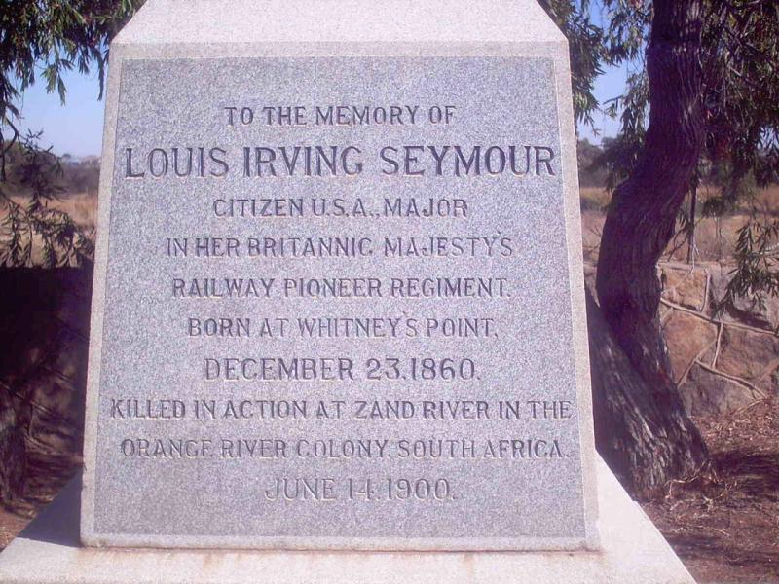

When Sir Alfred Moseley, who had made a fortune in the Kimberly diamond mines, about 1903 brought a group of English educators to this country to inspect American schools, he stated at a banquet given him in Boston that his admiration for American technical education dated from his observation of the prodigious feats of two young American engineers, one of whom was Louis Seymour. Oddly enough, Seymour had not enjoyed the advantages of technical education, but was an engineer by native endowment, an aptitude which amounted to genius.

He was said to be brilliant as an organizer. As an administrator and executive head, he commanded the unlimited confidence of all. He was a man of vivid personality, of enormous virility and vitality, with a magnificent physique; generous, kindly though masterful, honest and straight. He remained an American citizen and, though living much away from his native country, was always loyal, while strongly supporting the movement for understanding between the United States and Great Britain. After his death a committee was formed of his associates, including such men as John Hayes Hammond and Gardiner Williams, with Sir Alfred Milner as honorary president, to raise a Seymour Memorial Fund, with which was founded the “Seymour Technical Library” at Johannesburg. There’s also a Seymour Avenue named after him in the Parktown section of Johannesburg.”

Raymond B. Seymour

Raymond B. Seymour, PhD, is a scientist and educator whose discoveries have not only launched products and industries, but have also brought well-deserved recognition to the study of plastics.

At his high school graduation in 1929, Seymour was named an Edison Scholar after being personally tested by the great inventor. With his own extensive list of inventions, Seymour's career now calls Edison to mind. In addition to launching several polymer industries, his innovations include household items such as Band-Aids and disposable diapers, medical developments such as plastic casts and denture materials, and industrial improvements such as plastic pipe joints.

Working in industry and academia since 1937, Seymour has earned 45 U.S. patents, written or edited over 40 books and 1,700 journal articles, taught thousands of students, and developed a variety of plastics. He has worked for well-known firms including Monsanto, Goodyear, and Johnson and Johnson; has taught at several colleges and universities; and has presented seminars or short courses at major universities on five continents.

Lauded as the world's best-known plastics scientist, Seymour continues his work as a distinguished professor at the University of Southern Mississippi. He has received numerous honors, including election to the International Plastics Hall of Fame in 1988 and the International Gold Medal award from the Society of Plastics Engineers. He was recognized as a Chemist Pioneer by the American Institute of Chemists and earned an Excellence in Teaching Award from the Chemists Manufacturing Association, the Society of Plastics Engineers, and the University of Houston.

Stephanie Seymour (1969- ), Supermodel---More evidence of a decent gene pool? Although born in California, she’s ended up in Hartford. Maybe an ancient, irresistible family pull to the ancient roots?

Actually, I couldn’t find any evidence that she’s descended from Richard, but it’s a good bet. In any event, she’s somehow related, and I couldn’t resist……Below is a brief, fairly scandalous biography which displays a strong sense of independence, and utter lack of worry for what others might think about how she chooses to live her life. Sound familiar?

http://en.wikipedia.org/wiki/Stephanie_Seymour “Stephanie M. Seymour (born July 23, 1969) is an American model and actress. Seymour has modeled for many notable fashion magazines and designers, and has been photographed by several well-known photographers including Herb Ritts, Richard Avedon, Gilles Bensimon and most recently, Mario Testino. She has appeared on over 300 magazine covers.

Born in San Diego, California, the middle child of a California real estate-developer father and hairstylist mother, Seymour started her modeling career working for local newspapers and department stores in her hometown at the age of 14. In 1983, she entered the Elite Model Management Look of the Year modeling contest (now called Elite Model Look), but lost.

In the late 1980s and early 1990s, Seymour appeared in numerous issues of the Sports Illustrated swimsuit issue, and appeared on the cover of Vogue. During the same period, Seymour was a primary lingerie and hosiery model for the relatively new Victoria's Secret company in its mail-order catalogs and retail stores. In March 1991 and again in February 1993, Seymour posed for Playboy.
In 1998, she wrote Stephanie Seymour's Beauty Secrets for Dummies. In 2000, Seymour was ranked #91 on the North American FHM 100 Sexiest Women of 2000 list. In 2006, she appeared in a campaign for Gap with her children.

Salvatore Ferragamo's creative campaign for his fall/winter 2007/2008 collection featured Seymour and Claudia Schiffer, shot on location in Italy with Mario Testino. In the promotional photos, the supermodels play film stars protected by bodyguards and pursued by the paparazzi.

At the age of 16, she began dating John Casablancas, the head of Elite Model Management, who was, at the time, married to model Jeanette Christjansen. The couple lived together before Seymour broke off the relationship.

From 1989 to 1990 she was married to guitarist Tommy Andrews. The marriage failed, but resulted in the birth of her first son, Dylan Thomas Andrews, in 1991. Following her divorce, Seymour dated actor Warren Beatty.

By mid 1991, she became involved with Axl Rose, the lead singer of Guns N' Roses. She appeared in two music videos by Guns N' Roses: "Don't Cry" http://www.youtube.com/watch?v=zRIbf6JqkNc and "November Rain". http://www.youtube.com/watch?v=8SbUC-UaAxE The couple broke up in February 1993 after Rose accused Seymour of being unfaithful. The spokesman of actor Charlie Sheen confirmed rumors of a romance between Seymour and his client. In August 1993, Rose sued Seymour for assaulting him during a 1992 Christmas party, mental and emotional abuse, and for withholding $100,000 worth of jewelry. Rose claimed he and Seymour were engaged. In turn, Seymour countersued Rose for assaulting her and denied they were ever engaged.

Shortly after her break up with Rose, Seymour began dating Peter Brant, who was married and the father of five children. Brant is a publisher, real estate developer and art collector. She gave birth to the couple's first son (her second), Peter Jr., in December 1993. Seymour and Brant married in July 1995 in France. Seymour gave birth to their second son, Harry, in 1997 and to their third child, daughter Lily Margaret, in 2004. In March 2009, Seymour filed for divorce from Brant after almost 14 years of marriage.”

Chapter 10 – famous english cousins, Other direct
Descendents of sir john Seymour

In addition to the many already mentioned throughout, such as in the introduction, and in the chapter on the 16th century (Edward the Protector, Thomas, Jane, Edward VI, etc.), there are so many more that they couldn’t all be included here, but here are several more pages dedicated to some of the more notable. First let’s follow the Dukes of Somerset from Edward and Anne Stanhope down to the point where it passes back to Catherine Fillol’s line, and therefore closer related to our line--

Lord Henry Seymour was the son of Edward Seymour , 1st Duke of Somerset and Anne Stanhope
http://en.wikipedia.org/wiki/Lord_Henry_Seymour

Aboard HMS Rainbow he commanded the 'Narrow Seas' Squadron of ships that took part in the Battle of Gravelines against the Spanish Armada in 1588. Controlling the seas off Dunkirk they joined the main British fleet (the 'Western' Squadron) near Calais on 6 August, adding about a third to the total size.

Battle of Gravelines

The small port of Gravelines was then part of Flanders in the Spanish Netherlands, close to the border with France and the closest Spanish territory to England. Medina Sidonia tried to re-form his fleet there and was reluctant to sail further east knowing the danger from the shoals off Flanders, from which his Dutch enemies had removed the sea marks.

The English had learned more of the Armada's strengths and weaknesses during the skirmishes in the English Channel and had concluded it was necessary to close within 100 yards to penetrate the oak hulls of the Spanish ships. They had spent most of their gunpowder in the first engagements and had after the Isle of Wight been forced to conserve their heavy shot and powder for a final attack near Gravelines. During all the engagements, the Spanish heavy guns could not easily be run in for reloading because of their close spacing and the quantities of supplies stowed between decks, as Francis Drake had discovered on capturing the damaged Rosario in the Channel. Instead the cannoneers fired once and then jumped to the rigging to attend to their main task as marines ready to board enemy ships. In fact, evidence from Armada wrecks in Ireland shows that much of the fleet's ammunition was never spent. Their determination to thrash out a victory in hand-to-hand fighting proved a weakness for the Spanish; it had been effective on occasions such as the Battle of Lepanto and the Battle of Ponta Delgada (1582), but the English were aware of this strength and sought to avoid it by keeping their distance.

With its superior maneuverability, the English fleet provoked Spanish fire while staying out of range. The English then closed, firing repeated and damaging broadsides into the enemy ships. This also enabled them to maintain a position to windward so that the heeling Armada hulls were exposed to damage below the water line. Many of the gunners were killed or wounded, and the Spanish ships had more priests on board than trained gunners, so the task of manning the cannons often fell to the regular foot soldiers on board, who did not know how to operate the complex cannons. Sailors positioned on the upper decks of the English and Spanish ships were able to exchange musket fire, as their ships were in close proximity. After eight hours, the English ships began to run out of ammunition, and some gunners began loading objects such as chains into cannons. Around 4:00 PM, the English fired their last shots and were forced to pull back.

Five Spanish ships were lost. The galleass San Lorenzo ran aground at Calais and was taken by Howard after murderous fighting between the crew, the galley slaves, the English and the French who ultimately took possession of the wreck. The galleons San Mateo and San Felipe drifted away in a sinking condition, ran aground on the island of Walcheren the next day, and were taken by the Dutch. One carrack ran aground near Blankenberge; another foundered. Many other Spanish ships were severely damaged, especially the Spanish and Portuguese Atlantic-class galleons which had to bear the brunt of the fighting during the early hours of the battle in desperate individual actions against groups of English ships. The Spanish plan to join with Parma's army had been defeated and the English had afforded themselves some breathing space. But the Armada's presence in northern waters still posed a great threat to England.

Sir William Seymour, 2nd Duke of Somerset, KG (1588 – 24 October 1660-So he was the Earl of Hertford when Richard emigrated from Hertfordshire to America) was an English nobleman and Royalist commander in the English Civil War. http://en.wikipedia.org/wiki/William_Seymour,_2nd_Duke_of_Somerset
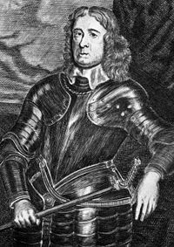

Seymour was the grandson of Edward Seymour, 1st Earl of Hertford and Catherine Grey, which thus gave him a distant claim to the throne through the latter's descent from Mary Tudor, younger sister of King Henry VIII of England. His parents were Edward Seymour, Lord Beauchamp of Hache, and Honora Rogers. William was the great-grandson of the first Duke of Somerset (Edward the Protector).

He married, firstly, Arbella Stuart, daughter of Charles Stuart, 1st Earl of Lennox and Elizabeth Cavendish, on 22 June 1610, in a secret marriage. Arbella was thirteen years his senior, and the marriage was disapproved of by King James (Stuart) I of England - the marriage of two potential pretenders to the throne, who were fourth and sixth in line to the English throne, could only be seen as a threat to the ruling dynasty. As a result, William was condemned to life imprisonment in the Tower of London (thus becoming the fourth of five generations of Seymours to spend time in the Tower). In June of 1611, he escaped from the Tower, and planned to meet up with Arbella and flee to the Continent; bad weather and other circumstances prevented their meeting, and Arbella was recaptured and herself placed in the Tower, while William managed to reach safety abroad (In France). Arbella died in 1615, without their ever being reunited.

Seymour, who succeeded his grandfather as Earl of Hertford in 1621, became a prominent member of the opposition to King Charles I in the House of Lords, supporting the Petition of Right of 1628, and co-signing the letter of the 12 Peers of 1640, along with his brother-in-law the Earl of Essex.

However, Hertford parted company with the more radical opponents of the King in the Long Parliament in 1641, and was created Marquess of Hertford by the King. In the Civil War, Hertford, along with such figures as Sir Edward Hyde, was a moderate royalist, and throughout sought a compromise settlement, continuing unofficial negotiations with his brother-in-law Essex, who became the Parliamentary commander, throughout the war. He was nevertheless a trusted supporter of the King, who made him guardian of his son the Prince of Wales, and who undertook several important military commands in royalist service over the course of the war, commanding troops from South Wales.

After the end of the First Civil War and the King's imprisonment, Hertford was the most prominent nobleman to remain alongside the king throughout his captivity, and was with him up until his execution in 1649 (an example of Seymour loyalty disregarding what’s popular in favor of what’s right). During the Interregnum, Hertford largely kept himself away from both politics and royalist conspiracies, believing that the monarchy would be restored given time, and that conspiracies would only delay the restoration.

When the Restoration came in 1660, Hertford was restored to all his former positions, and his services in the Royalist cause were further recognised by Charles II who restored Hertford to his great-grandfather's dukedom of Somerset which had been forfeited in 1552. He died at Essex House, London and was buried on 1 November 1660 at Great Bedwyn, Wiltshire. He was succeeded by his grandson William Seymour.

William Seymour, 3rd Duke of Somerset (1654 – 12 December 1671) was the son of Henry Seymour, Lord Beauchamp and Mary Capell.

He died in 1671, unmarried and childless and was succeeded by his paternal uncle John Seymour

John Seymour, 4th Duke of Somerset (before 1646 – 29 April 1675) was the son of William Seymour, 2nd Duke of Somerset and Lady Frances Devereux. He married Sarah Alston in 1656. He died in 1675, childless, and was succeeded by his patrilineal kinsman, Francis Seymour.

Francis Seymour, 5th Duke of Somerset (17 January 1658 – 20 April 1678), known as 3rd Baron Seymour of Trowbridge between 1665 and 1675, was an English peer.

He was the son of Charles Seymour, 2nd Baron Seymour of Trowbridge and Elizabeth Alington (1635–1692). He died aged 20, unmarried and childless, having been shot dead by Horatio Botti (a Genoese gentleman), whose wife Seymour is said to have insulted at Lerici. He was succeeded by his brother Charles Seymour.

Charles Seymour, 6th Duke of Somerset (13 August 1662 – 2 December 1748) sometimes referred to as the "Proud Duke". The son of Charles Seymour, 2nd Baron Seymour of Trowbridge, and Elizabeth Alington (1635–1692), he succeeded his brother Francis Seymour, 5th Duke of Somerset, to the dukedom when the latter was shot in 1678. He also inherited the title of Baron Seymour of Trowbridge.

Charles was educated at Trinity College, Cambridge. In 1682 he married a great heiress (Following ancient family tradition), Elizabeth Percy, daughter of Joceline Percy, 11th Earl of Northumberland, who brought him immense estates, including Alnwick Castle, Petworth House, Syon House and Northumberland House in London.
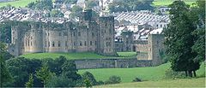Alnwick Castle, pleasant enough looking digs…
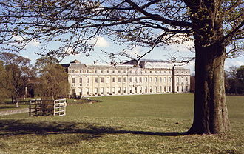Pentworth House, when one tires of the castle
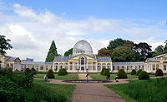Syon House,
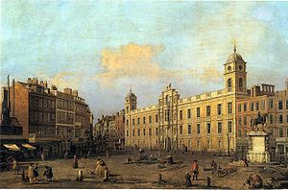Northumberland House, and on and on..

In 1683, Somerset received an appointment in the king’s household, and two years later a colonelcy of dragoons (similar to our American cousin in the Revolutionary War 90 years later); but at the Glorious Revolution he bore arms for the Prince of Orange. Having befriended Princess Anne in 1692, he became a favourite of hers after her accession to the throne, receiving the post of Master of the Horse in 1702. Finding himself neglected by Marlborough, he made friends with the Tories, and succeeded in retaining the queen’s confidence, while his wife replaced the Duchess of Marlborough as Mistress of the Robes in 1711.

In the memorable crisis when Anne was at the point of death, Somerset acted with Argyll, Shrewsbury and other Whig nobles who, by insisting on their right to be present in the Privy Council, secured the Hanoverian succession to the Crown.

He retained the office of Master of the Horse under George I till 1716, when he was dismissed and retired into private life; he died at Petworth on 2 December 1748. The duke’s first wife having died in 1722, he married secondly, in 1726, Charlotte, daughter of the 2nd Earl of Nottingham. He was a remarkably handsome man, and inordinately fond of taking a conspicuous part in court ceremonial; his vanity, which earned him the sobriquet of "the proud duke," was a byword among his contemporaries and was the subject of numerous anecdotes; Macaulay’s description of him as "a man in whom the pride of birth and rank amounted almost to a disease," is well known.

The Duke was a founding governor of the Foundling Hospital in London, 1739, the country's first and only children's home for foundlings (abandoned children).

General Algernon Seymour, 7th Duke of Somerset (11 November 1684 – 7 February 1750) was the son of Charles Seymour, 6th Duke of Somerset and his wife, Elizabeth. He was styled Earl of Hertford until he succeeded to the Dukedom in 1748.

In 1713, he married Frances Thynne, daughter of Thomas Thynne, 1st Viscount Weymouth, and they had two children:
George Seymour, Viscount Beauchamp (11 September 1725 – 11 September 1744), died young.
Elizabeth Seymour (1730 – 5 December 1776), married Hugh Percy, 1st Duke of Northumberland and had issue.

The Duke was one of the richest landowners in England, but as he died with no son his estates were split after his death. The ducal title passed to a distant cousin Edward Seymour, 8th Duke of Somerset. Most of the traditional Percy estates passed to his daughter and her husband (see Alnwick Castle, Northumberland House and Syon House). Petworth in Sussex passed to the duke's nephew Charles Wyndham, 2nd Earl of Egremont. Later dukes of Somerset lived at Maiden Bradley, a far more modest estate than those already mentioned.

Here is where the line went back to our side, after losing most of the land and castles, as Edward was also a descendent of Catherine Fillol and Sir John.

Sir Edward Seymour, of Berry Pomeroy, 6th Baronet, 8th Duke of Somerset, Earl of Hertford, Viscount Beauchamp, Baron Seymour (December 1694 or early 1695 – Maiden Bradley, Wiltshire, 12/15 December 1757, bur. 21 December 1757) was a British nobleman.

The son of Sir Edward Seymour, 5th Baronet, a descendant of Lord Protector Somerset by his first marriage, he was baptized at Easton, Wiltshire, on 17 January 1694 succeeded his distant cousin, Algernon Seymour, 7th Duke of Somerset, as 8th Duke of Somerset and Baron Seymour on 23 November 1750. The 8th Duke only inherited a fragment of the immense Percy family wealth enjoyed by his two immediate predecessors, and the Dukes of Somerset were never again amongst the richest landowning families in Britain. The principal Percy estates and houses of Alnwick Castle, Northumberland House, Petworth House and Syon House were divided between the 7th Duke's daughter and nephew.

Following Sir Edward were another series of family members, some of which didn’t accomplish very much in their lifetimes, and so have been omitted. From here on I’ll only include those who had more interesting lives than just being “old money”

Sir Edward Adolphus Seymour (later St. Maur), 12th Duke of Somerset, December 1804 or 1805, 28 November 1885)
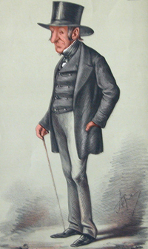Take a look at this character eh? He did qualify with a moderately more interesting life, though. Note that at this time, for a while, they changed their name back to St. Maur, which seems a little bit unSeymourly like, and ostentatious. This guy was obviously some type of mutant. Fortunately someone came along later and changed it back.

Somerset sat as Member of Parliament for Okehampton between 1830 and 1831 and for Totnes between 1834 and 1855. He served under Lord Melbourne as a Lord of the Treasury between 1835 and 1839, as Joint Secretary to the Board of Control between 1839 and 1841 and as Under-Secretary of State for the Home Department between June and August 1841 and was a member of Lord John Russell's first administration as First Commissioner of Woods and Forests between 1849 and 1851, when the office was abolished. He served on the Royal Commission on the British Museum (1847-49). In August 1851 he was appointed to the newly created office of First Commissioner of Works by Russell. In October of the same year he entered the cabinet and was sworn of the Privy Council. He remained First Commissioner of Works until the government fell in February 1852.

Somerset succeeded his father in the dukedom in 1855 and entered the House of Lords. He did not serve in Lord Palmerston's first administration, but when Palmerston became Prime Minister for a second time in 1859, Somerset was appointed First Lord of the Admiralty, with a seat in the cabinet. He held this post until 1866, the last year under the premiership of Russell. He refused to join William Ewart Gladstone's first ministry in 1868, but gave independent support to the chief measures of the government.

He was made a Knight of the Garter in 1862 and in 1863 he was created Earl St. Maur, of Berry Pomeroy in the County of Devon. "St Maur" was supposed to have been the original form of the family name and "Seymour" a later corruption. From some time in the early 19th century until 1923, "St. Maur" was used for the family name, but since 1923 the dukes have again used the familiar "Seymour".

Somerset was also the author of Christian Theology and Modern Scepticism (maybe my scepticism is hereditary, then) (1872), and Monarchy and Democracy (1880). Between 1861 and 1885 he served as Lord Lieutenant of Devon.

His elder son Ferdinand Seymour, Earl St. Maur, predeceased his father, without legitimate issue (his son Harold St. Maur later claimed the dukedom, however, see below). Their younger son, Lord Edward Seymour (1841-1865) was in the Diplomatic Service but died after being mauled by a bear in India, aged only 24 and unmarried.

The Duchess of Somerset died in December 1884. Somerset survived her by less than a year and died in November 1885, aged 80. As his two sons had both died in his lifetime, the family titles (except the Earldom of St. Maur, which became extinct) devolved on his younger brother, Lord Archibald St Maur.

Maj. Richard Harold St. Maur, of Horton, Chipping Sodbury, Gloucester (Brighton, Sussex, 6 June 1869 – 5 April 1927) Harold St Maur was born in Brighton in 1869, the illegitimate son of Edward Seymour, Earl St Maur, and grandson of Edward Seymour, 12th Duke of Somerset. His mother was a 19-year old half-gipsy maid named Rosina Elizabeth (oops, here we go again) Swan of Higham, near Bury St. Edmunds; St Maur's father died within months of his birth.

He was educated at Wellington College and Sandhurst, and served with the 14th Hussars and later with the 1st Division Royal Devon Yeomanry. He fought in the Boer War at Natal with the 7th Remounts and the Royal 1st Devon Imperial Yeomanry. St Maur wrote a book which he titled "Notebook for Officers and Non-Commissioned Officers of the Yeomanry".

He married in 1891, Elizabeth, daughter of Captain W.H. Palmer, of the 14th Hussars. There were three sons from the marriage. St Maur lived at Stover Park, near Newton Abbot, which he inherited from the Dukes of Somerset. He was a member of Newton Abbot Urban District Council, and was a member of parliament.

He served in the First World War, at Gallipoli, then in the campaign against the Senussi, and finally as liaison officer between Lord Allenby and the French Forces. For this work he was awarded the Legion of Honour and the Croix de Guerre with palms. He was Master of the South Devon Hounds (fox hunting) for many years.

In 1925, after the death of the 15th Duke of Somerset, St. Maur petitioned the House of Lords Committee for Privileges to safeguard his claim to the Dukedom, in the hope that he might find proof that his parents were legally married before his birth. On the death of his grandfather the 12th Duke in 1885, St Maur had been presumed illegitimate, and the Dukedom eventually passed to a distant branch of the family. He also placed advertisements in newspapers, offering a £50 reward for any witness to his parent’s marriage. Can’t blame a guy for trying...

St Maur died at Kipipili, Gilgil, Kenya, in 1927, aged 57. Sounds interesting but I can’t find out what he was doing there, or how he died.

Sir Evelyn Francis Edward Seymour, 17th Duke of Somerset, (1 May 1882 – 26 April 1954) was a British Army officer, landowner, peer, and for eight years Lord Lieutenant of Wiltshire. He was also a baronet. He was born in Colombo, Ceylon (Sri Lanka). Obviously my travel bug is in the blood as well.

Seymour served throughout the South African War and received the Queen’s medal with five clasps. He took part in the operations in the Aden Protectorate in 1903. So he was there when American cousin Louis Irving Seymour from Whitney Point, NY was there, and was shot and killed.

In April 1913, Seymour, then of the Royal Dublin Fusiliers, was appointed adjutant of the 25th (County of London) Cyclist Battalion the London Regiment, in which posting he continued until 1916, before returning to the Royal Dublin Fusiliers to take command of its 10th Battalion. In December 1917, he was promoted Acting Lieutenant Colonel. In 1918, he was awarded the DSO and in 1919 served in the Adjutant General's department of the War Office. He was appointed OBE in 1919 and retired the service in 1920. He succeeded to his father's dukedom in 1931.

During World War II, Somerset returned to the army. With effect from 1 November 1939, he was appointed a Lieutenant Colonel of the Devonshire Regiment, in which he commanded a battalion, and later held an appointment as a full colonel on the General Staff.

That about covers the interesting members of the ducal house. Following are some other distant cousins, who were more closely related as they were also descended through Catherine Fillol as well as Sir John, as were the Dukes of Somerset after 1750.

Francis Seymour-Conway, 1st Marquess of Hertford http://en.wikipedia.org/wiki/Francis_Seymour-Conway,_1st_Marquess_of_Hertford
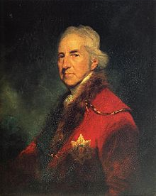

Francis Seymour-Conway, 1st Marquess of Hertford KG, PC, PC (Ire) (5 July 1718 – 14 June 1794) was born in Chelsea, London, and died in Surrey, England.

He was a descendant of Edward Seymour, 1st Duke of Somerset and his first wife Catharine Fillol. Their marriage was annulled and their children declared illegitimate. Their son Sir Edward Seymour (d. 6 May 1593) later served as a Sheriff of Devon.

The Sheriff of Devon was father to Sir Edward Seymour, 1st Baronet, grandfather of Sir Edward Seymour, 2nd Baronet, great-grandfather of Sir Edward Seymour, 3rd Baronet and a fourth-generation ancestor of Sir Edward Seymour, 4th Baronet.

The 4th Baronet was father to Sir Edward Seymour, 5th Baronet and grandfather to Edward Seymour, 8th Duke of Somerset. His younger son was Francis Seymour-Conway, 1st Lord Conway (1679–1732).

Lord Conway married Charlotte Shorter, a daughter of John Shorter of Bybrook. They were the parents of the Marquess. His father died when the younger Francis was about fourteen years old. The first few years after his father's death were spent in Italy and Paris. On his return to England he took his seat, as 2nd Baron Conway, among the Peers in November 1739. Henry Seymour Conway, politician and soldier, was his younger brother.

On 29 May 1741 he married Lady Isabella Fitzroy, daughter of Charles FitzRoy, 2nd Duke of Grafton, and they became the parents of thirteen children:
Francis Seymour-Conway, 2nd Marquess of Hertford (12 February 1743 – 28 June 1822)
Lady Anne Seymour-Conway (1 August 1744 – 4 November 1767), married Charles Moore, 1st Marquess of Drogheda.
Lord Henry Seymour-Conway (15 December 1746 – 5 February 1830)
Lady Sarah Frances Seymour-Conway (27 September 1747 – 20 July 1770), married Robert Stewart, 1st Marquess of Londonderry.
Lord Robert Seymour-Conway (20 January 1748 – 23 November 1831)
Lady Gertrude Seymour-Conway (9 October 1750 – 29 May 1782), married George Mason-Villiers, 2nd Earl Grandison.
Lady Frances Seymour-Conway (4 December 1751 – 11 November 1820), married Henry Fiennes Pelham-Clinton, Earl of Lincoln, a son of Henry Fiennes Pelham-Clinton, 2nd Duke of Newcastle.
Rev. Hon. Edward Seymour-Conway (1752–1785)
Lady Elizabeth Seymour-Conway (1754–1825)
Lady Isabella Rachel Seymour-Conway (25 December 1755 – 1825), married George Hatton, a Member of Parliament.
Admiral Lord Hugh Seymour (29 April 1759 – 11 September 1801), married Lady Anne Horatia Waldegrave, a daughter of James Waldegrave, 2nd Earl Waldegrave.
Lord William Seymour-Conway (29 April 1759 – 31 January 1837)
Lord George Seymour-Conway (21 July 1763 – 10 March 1848). He married Isabella Hamilton, granddaughter of James Hamilton, 7th Earl of Abercorn, and was the father of Sir George Hamilton Seymour, a British diplomatist.

A few of his children were soldiers and served in Parliament, but I’ll let you look most of them up yourself. The majority seemed to have married well and had lots of kids. The Bios of three of his sons follow, as I found them more interesting.

Career

In August 1750 he was created Viscount Beauchamp and Earl of Hertford. In 1755, according to Horace Walpole, 4th Earl of Orford, "The Earl of Hertford, a man of unblemished morals, but rather too gentle and cautious, to combat so presumptuous a court, was named Ambassador to Paris." However, due to the demands of the French, the journey was suspended.

From 1751 to 1766 he was Lord of the Bedchamber to George II and George III. In 1756 he was made a Knight of the Garter and, in 1757, Lord-Lieutenant and Guardian of the Rolls of the County of Warwick and City of Coventry.

In 1763 he became Privy Councillor and, from October 1763 to June 1765, was a successful ambassador in Paris. In the autumn of 1765 he became Viceroy of Ireland where, as an honest and religious man, he was well liked.

An anonymous satirist in 1777 described him as "the worst man in His Majesty's dominions", and also emphasised Hertford's greed and selfishness, adding "I cannot find any term for him but avaricious." However, this anonymous attack does not seem to be justified.

In 1782 when she was only fifty-six, his wife died after having nursed their grandson at Forde's Farm, Thames Ditton where she caught a violent cold. According to Walpole, "Lord Hertford's loss is beyond measure. She was not only the most affectionate wife, but the most useful one, and almost the only person I ever saw that never neglected or put off or forgot anything that was to be done. She was always proper, either in the highest life or in the most domestic." (Walpole visited Forde's Farm on several occasions from his residence at Strawberry Hill, Twickenham.) Within two years of the tragedy, Lord Hertford had sold Forde's Farm to Mrs Charlotte Boyle Walsingham, and a further two years later, she had re-developed the estate, building a new mansion which she called Boyle Farm, a name still in use today.

In July 1793 he was created Marquess of Hertford, with the subsidiary title of Earl of Yarmouth. He enjoyed this elevation for almost a year until his death at the age of seventy-six, on 14 June 1794, at the house of his daughter, the Countess of Lincoln. He died as the result of an infection following a minor injury he received while riding. He was buried at Arrow, in Warwickshire.

This son was notable since he served as Aide de Camp for General Clinton in the American Revolution.

Lord Robert Seymour (20 January 1748 – 23 November 1831) was a British politician, the third son of Francis Seymour-Conway, 1st Marquess of Hertford. He was known as Hon. Robert Seymour-Conway until 1793, when his father was created a marquess; he then became Lord Robert Seymour-Conway, but dropped the surname of Conway after his father's death in 1794.

Educated at Eton, he was commissioned an ensign in the 40th Regiment of Foot in 1766, and became a lieutenant in the 2nd Regiment of Irish Horse the same year. In 1770, he became a captain in the 8th Dragoons.

Seymour-Conway was returned for two Parliamentary seats in 1771: Lisburn, in the Parliament of Ireland, and the family borough of Orford in the British House of Commons. In 1773, he became a major in the 3rd Irish Horse.

By his first marriage, on 15 June 1773 to Anne Delmé, daughter of Peter Delmé, Seymour-Conway had five children:
Elizabeth Seymour (1775 – 23 February 1848), married first William Griffith Davies (1762–1814), on 10 December 1805, married second Herbert Evans (d. 1843) on 2 May 1817
Henry Seymour (c.1776 – 13 February 1843), married Hon. Emily Byng (d. 1824), daughter of George Byng, 4th Viscount Torrington, on 1 July 1800
Frances Isabella Seymour (d. 3 June 1838), married George FitzRoy, 2nd Baron Southampton
Anna Maria Seymour (22 September 1781 – ?)
Gertrude Hussey Carpenter Seymour (28 July 1784 – 3 January 1825), married John Hensleigh Allen on 12 November 1812

Seymour-Conway transferred into the 1st Foot Guards as a Captain-Lieutenant on 7 November 1775, and became captain of a company in the regiment on 30 January 1776. He gave up his seat at Lisburn that year, but continued to sit for Orford. He served as an aide-de-camp to Sir Henry Clinton in America from 1780 to 1781, but resigned his commission in 1782.

In Parliament, Seymour-Conway followed the rest of his family in supporting the North Ministry and the Fox-North Coalition, and opposing the ministry of Shelburne. In 1784, he turned over the Orford seat to his younger brother George, having purchased a seat at Wootton Bassett from Henry St John, who managed it. In 1787, he bought the estate of Taliaris in Llandeilo, Carmarthenshire, Wales which would become his principal seat.

He left his Commons seat in 1790, the year that he and his brother Henry were granted, for life, the sinecures of joint prothonotary, clerk of the crown, filazer, and keeper of the declarations of the King's Bench in Ireland. By 1816, these offices brought an income of more than £10,000 a year (about a million dollars per year in 2010).

He returned to Parliament for Orford in 1794, and continued to hold the seat until 1807. He took some interest in agriculture, as in 1796, he invented a new one-horse cart. On 2 December 1803, he was appointed Lieutenant-Colonel Commandant of the 2nd Battalion, Carmarthenshire Volunteers. He resigned that command on 6 January 1808.

After the death of his wife Anne, Seymour made a second marriage, on 2 May 1806, to Hon. Anderlechtia Clarissa Chetwynd (d. 1855), daughter of William Chetwynd, 4th Viscount Chetwynd, but they had no children.

During the 1807 election, Seymour was returned both for Orford and Carmarthenshire, choosing to sit for the latter, which he represented until 1820. On July 1, 1807, Seymour, who owned a house in Portland Place, was sworn a Justice of the Peace for Middlesex. He took an active role in civic affairs in London, and was for some time Director of the Poor for his parish of St Marylebone. This included a particular interest in the care and treatment of the insane, culminating in his appointment in 1827 to the commission superintending the building of Hanwell Asylum and as a Metropolitan Commissioner in Lunacy in 1828. However, he was now approaching the end of his life and played little active role as a Lunatic Commissioner. In 1829, Seymour funded the building of the north transept and a vicarage for Taliaris Chapel.

This son also caught my eye as he became quite rich with his brother also, and built a castle that was later used by Queen Victoria, and he had a reputation for being eccentric and benevolent
http://en.wikipedia.org/wiki/Lord_Henry_Seymour-Conway

Lord Henry Seymour (15 December 1746 – 5 February 1830) was a British politician, the second son of Francis Seymour-Conway, 1st Marquess of Hertford. He was known as Hon. Henry Seymour-Conway until 1793, when his father was created a marquess; he then became Lord Henry Seymour-Conway, but dropped the surname of Conway after his father's death in 1794.

Seymour-Conway was educated at Eton and Hertford College, Oxford, and took his MA from Merton College in 1767. He was first elected to the House of Commons in 1766 as Member for Coventry. He generally, though not always, voted with his uncle and namesake Henry Seymour Conway. After the 1768 election, when he and Andrew Archer defeated a challenge by Walter Waring, he was a consistent supporter of the Grafton and then the North governments.

Due to a falling-out between his father, the Earl of Hertford, and the Corporation of Coventry, Seymour-Conway did not stand as a candidate there at the 1774 election. He was instead returned by the North administration at Midhurst, which was a Treasury borough that year. In 1776, he was also returned to the Parliament of Ireland for Antrim County, which he represented until 1783. As his re-election in Midhurst did not appear to be sustainable in the 1780 election, he stood successfully at Downton. In the 1784 election, Seymour-Conway and Robert Shafto faced off against Hon. Edward Bouverie and William Scott, and, a double return being made, the case came before the House of Commons. Seymour-Conway chose not to stand in the ensuing by-election; his brother William took his place and won the by-election. During this period, he was for some time a captain in the Warwickshire Militia, and befriended the poet George Crabbe while quartered at Aldeburgh. On 11 February 1793, he was promoted major.

The election of 1784 marked Henry's retirement from politics. In 1790, he and his brother Robert were jointly granted, for life, the sinecures of joint prothonotary, clerk of the crown, filazer, and keeper of the declarations of the King's Bench in Ireland. By 1816, these offices brought an income of more than £10,000 a year (£587,713 as of 2011),. He spent the rest of his life in the improvement of his estate at Norris Castle, in the Isle of Wight. He had a reputation for both eccentricity and benevolence when he died, unmarried, in 1830. There is a memorial to him in St. Mildred's Church, Whippingham.

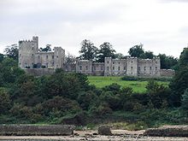Norris Castle, Queen Victoria stayed at Norris in her youth, and purchased the Osborne House, which is the next estate to the east.

Vice-Admiral Lord Hugh Seymour (29 April 1759 – 11 September 1801)
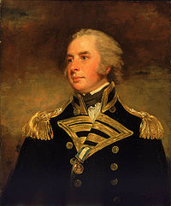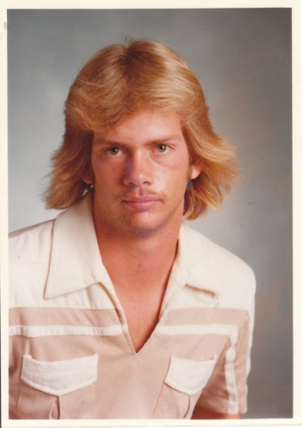Come on, you don’t see the resemblance? This is me at about 15, by the way, obviously no longer accepting Mom’s bowl haircuts, and trying to be a cool, independent surfer/football star. I was the only football player who didn’t have a military style crew cut. Always a rebel in those days. Back to cousin Hugh-

Vice-Admiral Lord Hugh Seymour was a senior British Royal Navy officer of the late eighteenth century who was the fifth son of Francis Seymour-Conway, 1st Marquess of Hertford and became known for being both a prominent society figure and a highly competent naval officer. He served during the American Revolutionary and French Revolutionary Wars and later in his career performed a period of shore duty on the Admiralty board.

Seymour maintained a reputation as a courageous and innovative officer: he was awarded a commemorative medal for his actions at the battle of the Glorious First of June and is credited with introducing epaulettes to Royal Navy uniforms as a method of indicating rank to non-English speaking allies. In his youth he formed close personal friendships with fellow officer John Willett Payne and George, Prince of Wales, through association with whom he gained a reputation as a rake. His marriage in 1785, made at the insistence of his family as an antidote to his dissolution, was brought about through royal connections and proved very successful. During his lifetime he also held several seats as a Member of Parliament in the Parliament of Great Britain, although he did not pursue an active political career.

Early career---Hugh Seymour was born in 1759 (1 year after our William Sr.) into one of the wealthiest families in England, as the fifth son of Francis Seymour-Conway, 1st Marquess of Hertford and his wife Isabella Fitzroy (Hugh retained the surname "Seymour-Conway" until his father's death in 1794, at which point he shortened it to Seymour). He was initially educated at Bracken's Academy in Greenwich, where he met lifelong friend John Willett Payne, before joining the Navy at age 11 at his own insistence. Seymour became a captain's servant on the yacht William & Mary, and two years later moved to HMS Pearl under his relation Captain John Leveson Gower, stationed off Newfoundland. After several short commissions, including service in the West Indies under George Rodney, Seymour was attached to HMS Alarm as a midshipman in the Mediterranean. Apart from a brief spell in HMS Trident, Seymour remained on her for several years, becoming a lieutenant in 1776. By 1776 the American Revolutionary War was underway, and Seymour continued in Alarm until he was made a commander in 1778, taking command of the xebec HMS Minorca. Xebecs were similar to galleys used by Berber corsairs and Barbary pirates having both lateen sails and oars for propulsion.

In 1779, Seymour was promoted once more, making post captain in HMS Porcupine and serving in command of HMS Diana, HMS Ambuscade and HMS Latona, all in the Channel Fleet. The only major operation in which he participated during the period was the conclusion of the Great Siege of Gibraltar, when Latona was attached to Lord Howe's fleet that relieved the fortress. During this service, Seymour was repeatedly engaged in scouting the Franco-Spanish fleet in Algeciras, a task made difficult by bad weather and the erratic movements of the enemy. During much of the operation, Captain Roger Curtis was stationed aboard Latona in order to facilitate communication between Howe and the Governor of Gibraltar. The effort to relieve and resupply the fortress was a complete success and Latona was sent back to Britain with dispatches, although Seymour remained in Gibraltar.

Following the Peace of Paris in 1783, Seymour took a house in London with his brother Lord George Seymour and John Willett Payne. The three men became notorious socialites, joining the Prince of Wales on many of his drinking exploits across London: Seymour remained close friends with Prince George for the rest of his life. Seymour, already known for his good looks, good manners, height and martial bearing (I had to put this in bold letters, he’s talking about Hugh, by the way), rapidly gained a reputation for dissolution (oops). In 1785 however, Seymour married Lady Anne Horatia Waldegrave, daughter of Earl Waldegrave and Maria Walpole (later Duchess of Gloucester) at the insistence of his family in a successful attempt to curtail his social activities. It was at this time that Seymour made his first foray into politics, becoming MP for Newport on the Isle of Wight before relinquishing the post two years later. In 1788 he became MP for Tregony, but in 1790 he switched to become MP for Wendover. Seymour remained in this position until 1796 when he changed his seat to Portsmouth, in which he remained until his death. He did not serve as an active politician in any of these positions, preferring his navy career to his political one.

French Revolutionary Wars---In the Spanish armament of 1790, Seymour was called to service in command of the ship of the line HMS Canada, opening his commission with a cruise off the Isle of Wight. Passing through shallow water, Seymour ordered the use of a lead line to measure the depth ahead, but was accidentally struck in the head by the lead weight while soundings were being taken. Although little immediate damage seemed to have been caused, during the firing of a salute several days later Seymour suddenly suffered a severely adverse reaction and had to be taken ashore for emergency medical treatment. The head injury rendered him unable to endure any loud noises or bright lights and for the next three years he lived as an invalid at his country estate in Hambleton. By 1793 he was sufficiently recovered to return to service, and escorted Lord Hood to the Mediterranean in HMS Leviathan. There Hood led the occupation, defence and ultimate withdrawal from Toulon during the Republican siege of the city. Following the collapse of the city's defences, Seymour was sent back to England with dispatches but returned shortly afterward to convoy Leviathan back to Britain.

Transferred to the Channel Fleet, Leviathan was attached to service under Lord Howe and served with him during the Atlantic campaign of May 1794 alongside John Willett Payne, captain of HMS Russell. The campaign culminated in the Glorious First of June, when a French fleet was defeated by Howe's innovative tactics, but was ultimately successful in protecting a large grain convoy from the United States. Seymour's command of Leviathan was vitally important in the victory, the ship fighting at the initial engagement of the 28 May and seeing extensive action during the battle itself. Seymour was one of only a few of Howe's commanders to successfully close with the French line, although he was unable to break through it. Leviathan then engaged closely with America, which she reduced to a battered wreck in a duel that lasted two hours. Leviathan was also badly damaged, having taken fire from Éole and Trajan during the fighting. At Howe's order, Seymour then left America (which was later captured) and joined the reformed fleet that held off a French counter-attack in the latter stages of the battle. In the aftermath of the action, Seymour was one of the captains marked out for praise, being presented with a medal commemorating his service during the engagement. Leviathan had suffered 11 killed and 32 wounded in the engagement.

In 1795, Seymour moved to the recently captured HMS Sans Pareil and soon became a rear-admiral, engaging the French at the Battle of Groix. During the action, Seymour managed to bring his ship to the head of the British line pursuing the French fleet and engaged the Formidable and Tigre. Both ships were captured in heavy fighting, and Sans Pareil suffered ten killed and two wounded during the exchange. In 1796, Seymour was employed in the search for the French fleet which attempted and failed to invade Ireland, but Sans Pareil was badly damaged in a collision with HMS Prince during the campaign and had to be decommissioned for extensive repairs. In April 1797, Seymour returned to sea with a small squadron of six ships searching the Eastern Atlantic for a Spanish treasure convoy. Although the convoy was eventually seized by a force sent by Lord St. Vincent, Seymour had covered over 5,000 miles in his fruitless search.

Admiralty service and death---Seymour had joined the Admiralty in 1795, becoming a Lord of the Admiralty and participating in much of the work the Admiralty board performed between 1795 and 1798, interposing his periods on land with brief sea commissions. In 1799, Seymour became a vice-admiral and joined the squadron blockading Brest for the next year, being involved in a minor operation against Basque Roads. In 1800 Seymour was sent to the West Indies as commander-in-chief of Jamaica but fell ill soon after arriving, contracting Yellow Fever. He was sent to sea by his doctors in an attempt to regain his health but died aboard HMS Tisiphone in September 1801.

Seymour's body was returned to Britain aboard HMS Sting and joined that of his wife, who had died in Bristol a few days before her husband's death. His extensive estates were dispersed amongst his seven children, one of whom, Sir George Seymour, later became an admiral himself. (Another son, Horace Beauchamp Seymour, was an ancestor of Diana, Princess of Wales through his grandson the 6th Earl Spencer.) Seymour's death was widely mourned among his contemporaries, Lord St. Vincent once describing him as "an excellent officer". His service had been energetic and characterised by innovation and invention: he developed a new system of fitting topmasts and was also credited with making epaulettes standard among Royal Navy officers, following his difficulties in convincing French Royalists at the Siege of Toulon that he was a British officer, due to his unimpressive uniform (never ostentatious, remember).

Field Marshal Henry Seymour Conway (1721 – 9 July 1795) was a British general and statesman. A brother of the 1st Marquess of Hertford, and cousin of Horace Walpole, he began his military career in the War of the Austrian Succession and eventually rose to the rank of Field Marshal (1793). http://en.wikipedia.org/wiki/Henry_Seymour_Conway
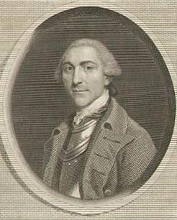

Family and education

Conway was the second son of Francis Seymour-Conway, 1st Baron Conway (whose elder brother Popham Seymour-Conway had inherited the Conway estates) by his third wife, Charlotte (daughter of John Shorter of Bybrook, Kent). He entered Eton College in 1732 and from that time enjoyed a close friendship with his cousin Horace Walpole.
Conway's English residence was Park Place at Remenham in Berkshire. On 19 December 1747 he married Caroline, the widow of Charles Bruce, 4th Earl of Elgin and 3rd Earl of Ailesbury, and daughter of Lieutenant-General John Campbell, later the 4th Duke of Argyll. They had one daughter, the sculptor Anne Seymour Damer.

Early army career

Conway joined the Molesworth's Regiment of Dragoons in 1737 as a Lieutenant, being promoted to Captain-lieutenant (the equivalent of lieutenant-colonel) in the 8th Dragoons in 1740. During the War of Austrian Succession he served as a captain-lieutenant in the 1st Foot Guards in 1743 at Dettingen, but missed the fighting by his regiment being in the rearguard. In 1745 he fought at Fontenoy, distinguishing himself, when only 24 of his company survived. He was engaged in Culloden in 1746 during the Jacobite Rebellion. His next battle was at Lauffeld, in which he narrowly escaped death, being captured by the French but released on parole three days later. In 1748, he transferred from the 48th Foot to the 34th Foot, and served with his regiment in the garrison of Minorca in 1751.

Early political career

Conway entered politics at an early age. He was elected unopposed to the Irish Parliament in 1741 for Antrim County, and to the British Parliament for Higham Ferrers in 1741 on the recommendation of Sir Robert Walpole. In this period he spent his winters in Parliament and his summers on active military service. He was elected in 1747 for Penryn and for St Mawes in 1754, both in the Boscawen interest.

In 1755, he was unexpectedly appointed Chief Secretary for Ireland by William Cavendish, Marquess of Hartington, the new Lord Lieutenant. He then finally took his seat for County Antrim in the Irish House of Commons. It was hoped that he would resolve the conflict in Irish politics between the Speaker, Henry Boyle on the one side and George Stone, Archbishop of Armagh and the Ponsonby family. Ultimately, he reached a compromise, acceptable to the British Ministry, in which Boyle was bought off with an earldom and John Ponsonby became Speaker. He was promoted a Major-General in 1756 and returned to England in May, but remained an Irish MP until 1761. He became a Lord of the Bedchamber in 1757.

Seven Years War
Further information: Great Britain in the Seven Years War

Conway was the British military second in command on the Rochefort expedition in 1757, and repeatedly advocated an attack on Fort Fouras, but his colleagues would only agree a night attack (which failed). He then refused to take sole responsibility for a day attack. Ultimately the expedition returned to Portsmouth having achieved nothing. Though Mordaunt (the commander in chief) was acquitted by his court martial, the affair damaged both their reputations. In his displeasure, George II refused to employ Conway on the 1758 campaigns. He was not employed again until the next reign, except that he was sent to sign a cartel for an exchange of prisoners at Sluys in 1759.

In 1761, he served in Germany as deputy to John Manners, Marquess of Granby, the British commander in the army led by Ferdinand of Brunswick. He commanded a corps at the Battle of Vellinghausen, which was at the centre of the line and not attacked. He was also present at the Battle of Wilhelmsthal in June 1762, and captured the castle of Waldeck the following month. After peace preliminaries were signed at Fontainebleau in November, he supervised the embarkation of British troops from Europe, returning to England in March.

Later political career

Conway was mentored in his political career by his cousin Horace Walpole. He was re-elected to the House of Commons in 1761, this time for Thetford, which he represented until 1774. Like Walpole he was a senior member of the Rockingham faction of the Whigs. He opposed the King's action against John Wilkes in 1763, to declare this a breach of Parliamentary Privilege. This resulted in his dismissal as a Groom of the Bedchamber and as Colonel of the 1st Dragoons. This led to the publication of pamphlets, as it was feared that the government intended to purge the army of its political opponents.[2]

He entered office with Lord Rockingham as Secretary of State for the Southern Department in 1765 before switching to the Northern Department the next year, serving until his resignation in 1768. In these offices, Conway sought to urge a moderate policy towards the American colonies, being the principal supporter of the repeal of the Stamp Act in 1766, and opposing the taxation policies of Chancellor of the Exchequer Charles Townshend.

Return to the Army

Following his resignation in January 1768, Conway returned to the military, and in 1772 was made a full general and Governor of Jersey. He remained an important figure in the Commons, opposing the British attempt to suppress the American Revolt, and his motion in March 1782 was partly responsible for the fall of the North government. He was rewarded with a cabinet position and the office of Commander-in-Chief in the new Rockingham ministry, but left the government a year later with the establishment of the Fox-North Coalition. His political career came to an end in 1784 when he lost his seat in parliament due to his opposition to the new government of William Pitt.

Sir Michael Seymour, 1st Baronet KCB (8 November 1768 – 9 July 1834) was an officer of the Royal Navy. He served during the French Revolutionary and the Napoleonic Wars, eventually rising to the rank of Rear-Admiral.
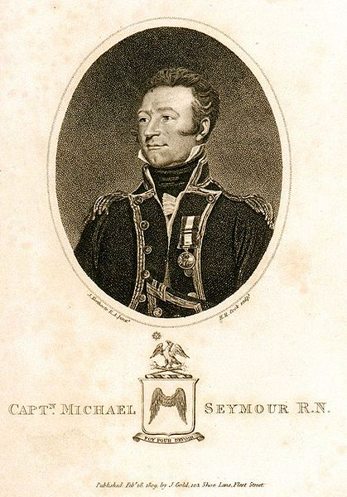Here with the same seal as used by GGG++ Grandpa Thomas in Connecticut

Family and early life--Seymour was born in Palace, County Limerick on 8 November 1768, the second son of Reverend John Seymour and his wife Griselda. He joined the navy at the age of 12, serving as a midshipman aboard the sloop-of-war HMS Merlin, in the English Channel, under Captain James Luttrell. Seymour moved with Luttrell to HMS Portland in 1781. The Portland was then serving as the flagship of Rear-Admiral Richard Edwards, then the commander-in-chief at Newfoundland. Edwards was replaced by Vice-Admiral John Campbell in 1782, and both Luttrell and Seymour moved aboard HMS Mediator. The Mediator then returned to Britain to cruise off the French coast.

On 12 December 1782 the Mediator pursued five French frigates in the Bay of Biscay. The French formed a line of battle, confident in their superior numbers, but Luttrell engaged them, breaking their line. He overhauled one and captured her, the 24-gun Alexander, with 120 crew aboard. The remainder then fled, pursued by Luttrell. They then split up, forcing Luttrell to choose to remain with the largest. He eventually caught up with her and brought her to battle. The enemy, the 34-gun Menegere with 212 men aboard, was forced to surrender. Luttrell began the return voyage to England with his prizes, having to deal with an attempted uprising amongst his French prisoners part way through the voyage on 14 December. Despite having only 190 men to deal with 340 prisoners, the rising was quashed without bloodshed. Seymour remained aboard the Mediator until 1783, when he moved to HMS Ganges. He eventually served on a number of different ships, before receiving his commission as a lieutenant in 1790. He joined HMS Magnificent that year, but left when she was paid off in 1791.
Advancement--Seymour returned to service with the outbreak of the French Revolutionary Wars in 1793, serving aboard HMS Marlborough under George Cranfield-Berkeley. The Marlborough formed part of the fleet under Lord Howe, and Seymour was thus present at the Glorious First of June, on 1 June 1794. During the battle, the Marlborough came under attack from three French warships, the 78-gun Impétueux, the 74-gun Mucius and the 120-gun Montagne. The Marlborough was heavily damaged but was able to defend herself and resist French attempts to capture her. During the battle Seymour had his left arm shot off. I wonder if they installed a hook. Naaahh.

Seymour recovered from his wound, and was promoted to commander. He received his first command in mid 1796, that of the sloop HMS Spitfire. He spent the next several years cruising in the Channel, and off the French coast, before being promoted to Post-Captain on 11 August 1800, after making representations to the First Lord of the Admiralty George Spencer. During his time in home waters he was able to capture a number of small French ships and privateers. He moved to take command of HMS Fisgard in 1801, at the instigation of Admiral William Cornwallis, but the Peace of Amiens later that year left him without a ship. The resumption of hostilities led to Seymour returning to sea, spending time as acting-captain of a number of ships, before finally being offered command of the 36-gun fifth rate HMS Amethyst in 1806. On 10 November 1808 he came across the 40-gun French frigate Thetis, and after a hard fought battle, captured her. In recognition of this act Seymour received a medal from King George III, a 100 guinea piece of plate from the Lloyd's Patriotic Fund, and the Freedom of the Cities of Cork and Limerick. On 6 April 1809 he captured the 44-gun frigate Niemen. For this he was created a baronet the following month.

Later career--Seymour then served on the Walcheren Campaign, and on its conclusion, was appointed to command his prize, HMS Niemen, which had subsequently been taken into the navy. He then commanded the 74-gun third rate HMS Hannibal, and on 26 May 1814 he captured the 44-gun Sultane. He was nominated a Knight Commander of the Order of the Bath in January 1815 and moved aboard the Royal Yacht several years later. He became Commissioner of Portsmouth Dockyard, but after the post was abolished, was promoted to Rear-Admiral, and appointed to command the South American Station. He received a pension of £300 for the loss of his arm.
Death--Seymour was already in poor health on his departure from England, and died at Rio de Janeiro on 9 July 1834. He was buried at Gamboa on 15 July in a large funeral attended by English, French, American and Spanish officers, and other civilian officials. As a gesture of respect, the national flags on the ships in the harbour were flown at half-mast, and salutes were fired. A memorial was later erected in his memory at St Anns Church, Portsmouth.

Family--Michael Seymour's younger brother, Richard, also joined the navy, reaching the rank of lieutenant. He served aboard HMS Amazon but was killed in the battle against the French frigate Belle Poule on 13 March 1806. Michael Seymour married Jane in 1797, and the couple had five sons and three daughters. His eldest son, John, inherited the baronetcy on his father's death. His third and fourth sons, Michael and Edward, followed their father into the navy. Michael had a distinguished career, rising to the rank of Admiral. Edward served briefly as flag lieutenant under his father, but died relatively young, and was posthumously promoted to commander

Admiral Sir Michael Seymour GCB RN (3 December 1802 – 23 February 1887 near Horndean)
was a British admiral and the uncle of Sir Edward Hobart Seymour, also an admiral. He was the third son of Admiral Sir Michael Seymour, 1st Baronet.
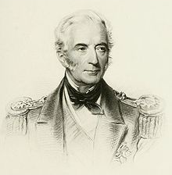
Michael Seymour entered the Royal Navy in 1813. He made Lieutenant in 1822, Commander in 1824 and was posted Captain in 1826. From 1833 to 1835 he was captain of the survey ship HMS Challenger, and was wrecked in her off the coast of Chile. From 1851 to 1854 he was Commodore Superintendent of Devonport Dockyard. In 1854 he served under Sir Charles Napier in the Baltic during the Crimean War, in the capacity of Captain of the Fleet. He was promoted to Rear-Admiral that same year and, when the Baltic campaign was resumed in 1855 under Admiral the Hon. Richard Saunders Dundas, Seymour was second in command, flying his flag in HMS Exmouth. He was made KCB at the end of 1855.

On 19 February 1856 he was appointed commander-in-chief of the East Indies station, which included the coast of China. Flying his flag in HMS Calcutta, he conducted the operations arising out of the affair of the lorcha Arrow (Second Opium War); he helped destroy the Chinese fleet in June 1857, took Canton in December, and in 1858 he captured the forts on the Pei Ho (Hai River), compelling the Chinese government to consent to the Treaties of Tianjin. He was made GCB in 1859. He sat as a Liberal Member of Parliament for Devonport from 1859 to 1863. In 1864 he was promoted to the rank of admiral and was Commander-in-Chief, Portsmouth, till 1866. He retired in 1870.

Admiral of the Fleet Sir Edward Hobart Seymour GCB OM RN (30 April 1840–2 March 1929). 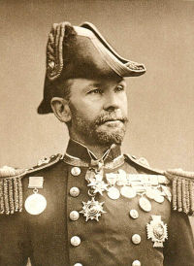

He was the grandson of Rear-Admiral Sir Michael Seymour, 1st Baronet, and nephew of Admiral Sir Michael Seymour. He was educated at Radley College and Eastman's Naval Academy, Southsea.

He served in the Black Sea until the evacuation of Crimea in 1856. After the end of the Crimean War, still a midshipman, he was appointed to the HMS Calcutta, flagship of his uncle Sir Michael Seymour, on the China station. He took part in the capture of Canton (December 1857). In HMS Chesapeake Seymour took part in the attack on the Taku forts in September 1860.

In December 1897, Seymour was appointed commander-in-chief on the China Station, though he did not assume command until 18 February 1898. His flagship was the battleship HMS Centurion. Service there was peaceful until the Boxer Rebellion. Seymour led the Naval Brigade in the relief of Peking. As of March 1901, Seymour's command on the China Station in March 1901 consisted of:
Battleships: Centurion, Barfleur (Rear-Admiral Sir James A. T. Bruce, K.C.M.G. second in command), Glory, Goliath, Ocean.
1st Class cruisers: Argonaut, Aurora, Blenheim, Endymion, Orlando , Terrible, Undaunted.
2nd Class cruisers: Arethusa ‡, Astraea ‡, Bonaventure, Dido, Hermione, lsis, Pique.
3rd Class cruisers: Alacrity, Wallaroo ‡.
Destroyers: Fame, Hart, Otter, Whiting.
Sloops: Algerine, Daphne, Phoenix, Rosario.
Gunvessel: Linnet.
Gunboats: Bramble, Brisk, Britomart, Esk , Lizard ‡, Pigmy, Plover, Redpole.[3]
Storeship: Humber.
Receiving ship Hong Kong: Tamar (flagship of the Commodore in charge at Hong Kong, Commodore Francis Powell, C.B)
River steamers: Robin, Sandpiper, Snipe, Woodcock, Woodlark.

"Seymour was a man of a singularly broad and humane outlook...He was widely read and a good linguist. He described his services with great modesty and a total lack of self-consciousness in My Naval Career and Travels (1911). He was unmarried."
At the time of his death, he was the last living of the original (1902) members of the Order of Merit.

Colonel Sir Horace Beauchamp Seymour (22 November 1791 - 23 November 1851) was a Peelite Member of Parliament for Lisburn, Antrim, Oxford, Bodmin and Midhurst.

He was invested as a Knight Commander, Hanoverian Order (K.C.H.) and gained the rank of Colonel in the service of the British Army.

By his first wife he had three children;
Lt.-Col. Charles Francis Seymour (13 Sep 1819 - 5 Nov 1854), killed at the Battle of Inkerman
Frederick Beauchamp Paget Seymour, 1st Baron Alcester (12 Apr 1821 - 30 Mar 1895)
Adelaide Horatia Elizabeth Seymour (27 Jan 1825 - 29 Oct 1877), who married Frederick Spencer, 4th Earl Spencer and was an ancestor of Diana, Princess of Wales. Therefore Princess Di had some Seymour blood as well:

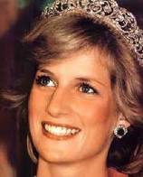

Admiral Frederick Beauchamp Paget Seymour, 1st Baron Alcester, GCB (12 April 1821 – 30 March 1895) Nickname: The ocean swell
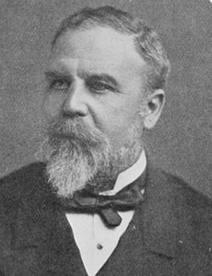
was a British admiral. He was the son of Colonel Sir Horace Seymour and a cousin of the 5th Marquess of Hertford. He was a great-grandson of the 1st Marquess of Hertford.

He entered the Royal Navy in 1834, and served in the Mediterranean and the Pacific, and was for three years was aide-de-camp to his uncle Sir George Seymour, and was promoted to Commander in 1847. He also served in Burma. He was the Commander-in-Chief of the Australia Station from 10 March 1860 and 21 July 1862 as Commodore second class with his pennant aboard HMS Pelorus. He commanded the Naval Brigade in New Zealand during the Maori Wars of 1860-61, and was made a Commander of the Bath for this.

In 1872, he became a Lord of the Admiralty for two years, and then commander the Channel fleet. He became a Vice-Admiral on 31 December 1876, and was appointed KCB in June 1877, and was promoted to GCB on 24 May 1881. From 1880 to 1883 he was Commander-in-Chief of the Fleet in the Mediterranean. He became an Admiral in May 1882.

He was created Baron Alcester (pronounced "Allster"), of Alcester in the County of Warwick, in 1882 for his command of the bombardment of Alexandria and in the subsequent operations on the coast of Egypt. He was also honoured with a parliamentary grant of £25,000, the Freedom of the City of London and a Sword of Honour. He died unmarried and his peerage became extinct.”

http://www.telegraph.co.uk/news/obituaries/royalty-obituaries/8120671/Major-Raymond-Seymour.html Here’s a more modern story
Major Raymond Seymour who died on October 6, 2010 aged 87, held the rare distinction of having served as page of honour to three monarchs: George V, Edward VIII and George VI.
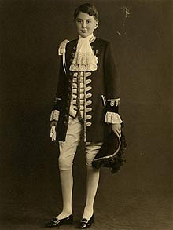

As such he was one of the train bearers to George VI at the 1937 Coronation. He was then attached to Queen Elizabeth the Queen Mother's Household from 1954 until her death in 2002.
Raymond Seymour as a page of honour

George Raymond Seymour was born on May 5 1923 into a family which descended from the Marquesses of Hertford, the Dukes of Somerset and ultimately from Henry VII and which had a tradition of serving the Royal family.

Raymond's father, Lt-Col Sir Reginald Seymour, was an Equerry to George V from 1916 and after the King's death served Queen Mary in the same capacity until he died in 1938.

Raymond's mother, Winifred, died when her son was two, and his father then married Lady Katharine Hamilton, daughter of the 3rd Duke of Abercorn. She had been a girlhood friend of the Queen Mother, and subsequently became an Extra Woman of the Bedchamber. Raymond was very fond of his stepmother, who brought him up with her own three children.

He was educated at Eton and was on observation duty for the Home Guard in 1940 when bombs and incendiaries fell close by on Upper School and damaged the chapel. In 1941 he joined the King's Royal Rifle Corps but was injured during training. Later he was ADC to Major-General Walter Clutterbuck in Northern Ireland and Cairo. After the war Seymour served in Palestine and Germany, reaching the rank of major.

In 1954 he joined Whitbread's, but was almost immediately seconded as an Equerry to Queen Elizabeth the Queen Mother, whose Household had recently been established at Clarence House. His duties included attending on Princess Margaret, who lived with her mother before she married in 1960. He returned to Whitbread's after two years but continued to work informally for Queen Elizabeth until formally appointed an Extra Equerry in 1984.

Following the death in 1993 of the Queen Mother's long-serving Private Secretary, Sir Martin Gilliat, he was appointed Assistant Private Secretary and Equerry, working under Sir Alastair Aird. At Clarence House he was considered a supportive, unflappable and amusing colleague. He shared the Queen Mother's keen interest in racing, and was on duty for the first week of her annual fishing fortnight at Birkhall, near Balmoral, each May.

At Whitbread's, Seymour was responsible for setting up its wine and spirits division and for sponsorship, of which Whitbread's was an early pioneer in this country. This included Sir Francis Chichester's first single-handed circumnavigation of the world, the Whitbread Round the World Race, the Badminton Horse Trials and the men's tennis tournament at Queen's. He retired from Whitbread's as deputy chairman in 1983.

In 1957 he married Mary Finnis, daughter of General Lord Ismay, KG. Mary was a young widow with two daughters, and she and Seymour had a daughter together.

The family lived in London, but later moved to Bucklebury, near Reading. Seymour was High Sheriff of Berkshire in 1989 and a Deputy Lieutenant from 1992.

Seymour had a home on the Isle of Wight from 1960, and was a former commodore and trustee of the Bembridge Sailing Club; he was instrumental in preserving the class of Bembridge One Design keel boats.

His wife, their daughter and his stepdaughters survive him.

Okay, after looking at all of the Seymours, both British and American, if you don’t see the obvious relationship, between the Admirals in England, and the Generals in the US, the members of Parliament in England, and the Governors and Congressmen in America, and on and on, then you’re just not going to ever be convinced. I, however, am completely convinced.
I didn’t set out to draw this conclusion. Remember that I was just trying to find out who my Great-Great Grandfather was. Now I’m sure that I’ve traced the tree back to before the year 1000 to a man called Goscelin de St. Maur, a Frenchman, from Ste. Maur Sur, Loire, France. And to his French-Norman GG Grandson, Wido St. Maur, a knight who conquered England along with William the Conqueror, and then set up shop at Penhow Castle on the Welsh frontier.

